Supplementary data

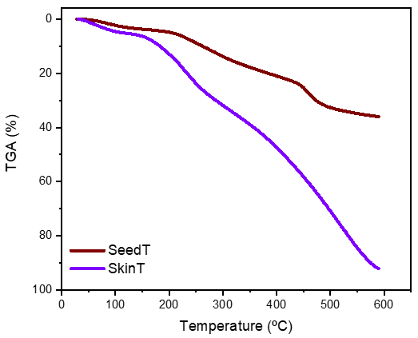
Figure S1. Thermogravimetric analysis (TGA) results of seed tannin (SeedT) and skin tannin (SkinT) extracts. TGA (TGA-50H, Shimadzu) was carried out in oxidizing (air) atmosphere from 25-600°C at a heating rate of 10°C/min.
Figure S1 shows that the temperature (60°C) used in the film preparation method (solution casting) did not compromise the stability of tannin extracts. At that temperature, weight losses of only 0.5 and 1.8 % were seen with the SeedT and SkinT extracts, respectively, which were mainly related to the loss of moisture.

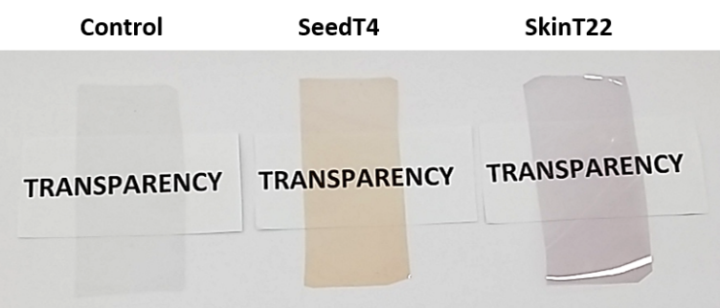
Figure S2. The appearance of gelatin films without tannin extracts (control), and with 4% seed tannin (SeedT4) and 22% skin tannin (SkinT22) extracts.

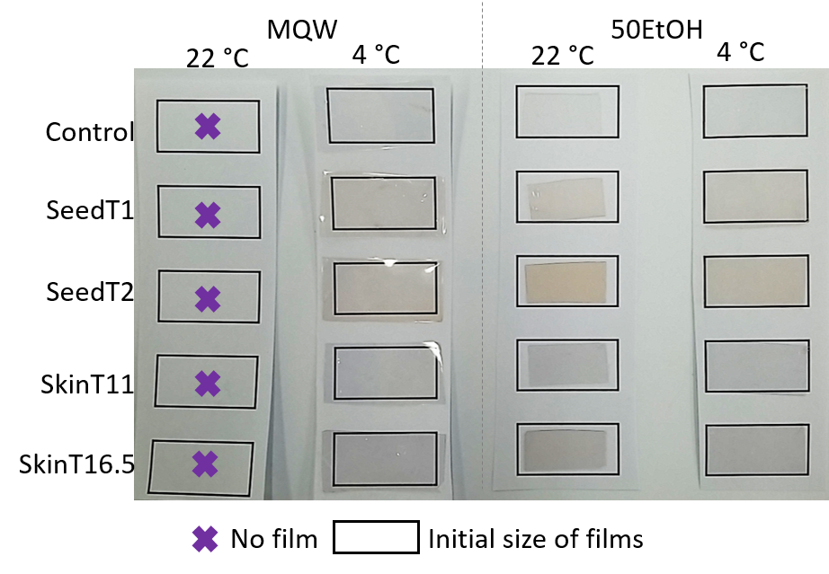
Figure S3. The appearance of dry gelatin films without tannin extracts (control), and with 1 & 2% seed tannin (SeedT1 & SeedT2) and 11 & 16.5% skin tannin (SkinT11 & SkinT16.5) extracts after immersion in Milli-Q water (MQW) and 50 % (v/v) ethanol (50EtOH) food simulants for 24 h at different storage temperature to simulate chilled (4 °C) and ambient (22 °C) commercial food storage conditions.

Table S1. Polyphenolic composition of the seed tannin (SeedT) and skin tannin (SkinT) extracts expressed in percentage. Monomeric phenolic compounds and tannin subunit composition were determined using the HPLC method; tannin concentration was determined by the methylcellulose tannin precipitation assay; and polymeric pigments were measured with the Harbertson–Adams assay as outlined in our previous works (Yang, Deed, Araujo, Waterhouse, Kilmartin, 2021 a & b).
 |  |  |  |  |  | Extension Unit  (mole %) |  |  |  | Terminal Unit  (mole %)
Polymeric phenolics | PP  (%) | Tannin  (%) | mDP | %Tri-OH†† | %Galloyl‡‡ | EGC | CAT | EPI | ECG | CAT | EPI | ECG | Yield (%)
SeedT | 0.0 ± 0.0 | 62.6 ± 0.9 | 2.6 ± 0.1 | 6 ± 2 | 17 ± 0 | 6 ± 2 | 11 ± 0 | 40 ± 2 | 14 ± 0 | 16 ± 1 | 10 ± 0 | 3 ± 0 | 49 ± 2
SkinT | 3.9 ± 1.1 | 1.2 ± 0.1 | 4.6 ± 0.3 | 38 ± 6 | 36 ± 7 | 38 ± 6 | 3 ± 0 | 15 ± 1 | 30 ± 7 | 5 ± 1 | 4 ± 0 | 6 ± 0 | 66 ± 6

Monomeric phenolics | Gallic acid (%) | (+)-catechin (%) | (-)-epicatechin (%)
SeedT | 0.1 ± 0.0 | 1.5 ± 0.1 | 0.4 ± 0.0
SkinT | < D.L. | 0.4 ± 0.0 | < D.L.

PP, polymeric pigments (polyphenolic containing anthocyanins within their structure) determined at 520 nm; mDP, the mean degree of polymerization; %Tri-OH, the percentage of trihydroxylation; %Galloyl, the percentage of galloylation; Extension and Terminal Units (mole%): EGC, (-)-epigallocatechin, CAT, (+)-catechin, EPI, epicatechin and ECG, (-)-epicatechin gallate; D.L., detection limit.

References:
Y. Yang, R.C. Deed, L.D. Araujo, A.L. Waterhouse, P.A. Kilmartin, Effect of microoxygenation on acetaldehyde, yeast and colour before and after malolactic fermentation on Pinot Noir wine, Aust. J. Grape Wine Res. (2022a), 28, 50-60. https://doi.org/10.1111/ajgw.12512
Y. Yang, R.C. Deed, L.D. Araujo, A.L. Waterhouse, P.A. Kilmartin, Effect of microoxygenation applied before and after malolactic fermentation on monomeric phenolics and tannin composition of Pinot Noir wine, Aust. J. Grape Wine Res (2022b), 28, 95-106 https://doi.org/10.1111/ajgw.12520

Table S2. Values of gallic acid (GA) equivalent (GAE) for total phenolic content (TPC) assay (extracts concentration 1 mg/mL), and values of inhibition and GAE for the DPPH assay (extract concentration 55 µg/mL).
 | TPC |  | DPPH
Extract | mg GA/g extract |  | Inhibition* (%) | mg GA/g extract
SeedT | 437 ± 1 |  | 20 ± 2 | 491 ± 51
SkinT | 14 ± 3 |  | 2 ± 0 | 44 ± 10
*Inhibition values of tannin extracts solutions (55 µg/mL) diluted (25/1000) in 75 µM DPPH solution

