Supplementary information of Enhanced behaviour of a passive thermoelectric generator with phase change heat exchangers and radiative cooling

David Astrain*(a), Juliana Jaramillo-Fernandez†(b), Miguel Araiz(a), Achille Francone(b), Leyre Catalán(a), Alejandra Jacobo-Martín(b), Patricia Alegría(a), Clivia M. Sotomayor-Torres (b,c)

A. Influence of the radiative coating on the optical properties of a copper surface
The optical properties of heat pipes cannot be directly measured by using UV/vis and FTIR spectrometry since they are cylindrically shaped, because these characterization techniques are designed for flat samples. However, the optical properties of a bare copper slab with and without coating can provide insight about the effect of the radiative coating. Thus, to assess the change of the optical properties of copper due to the radiative surface treatment, the optical properties of a reference Copper slab, bCu, were compared to the optical properties of another Cu slab with identical dimensions, covered with the radiative coating, Cu RC, as shown below:
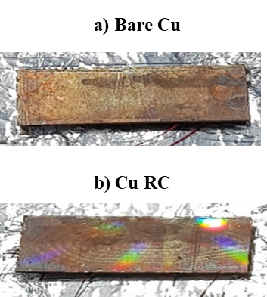
Figure S1. a) Bare and b) radiative coated copper slabs. The rainbow colours appearing on the radiative coated slab result from the light diffraction due to the periodic structure.
The optical properties in the UV/vis spectra were measured from 200 to 900 nm using a Cary 4000 spectrometer equipped with an integrating sphere. The emittance of the copper slabs in the mid-IR was measured by FT-IR spectroscopy, using a gold integrating sphere to collect the near-normal reflected and scattered light over a solid angle of 2𝜋 sr, from wavelength of 0.9 to 25 μm. The approach to obtain the emittance was by measuring the absorptance A, the fraction of radiation absorbed by the surface. It was assumed that the directional spectral emittance was equal to the directional spectral absorptance, ϵ(𝜆, 𝜃, ϕ) = A(𝜆, 𝜃, ϕ) under thermodynamic equilibrium, according to the Kirchhoff’s law of thermal radiation. The absorptance was obtained by taking the difference of the measured reflectance of the samples in the infrared spectrum from unity (A = 1 – R, T=0 as the slabs are 3mm thick). The obtained spectra are presented in the following figure:

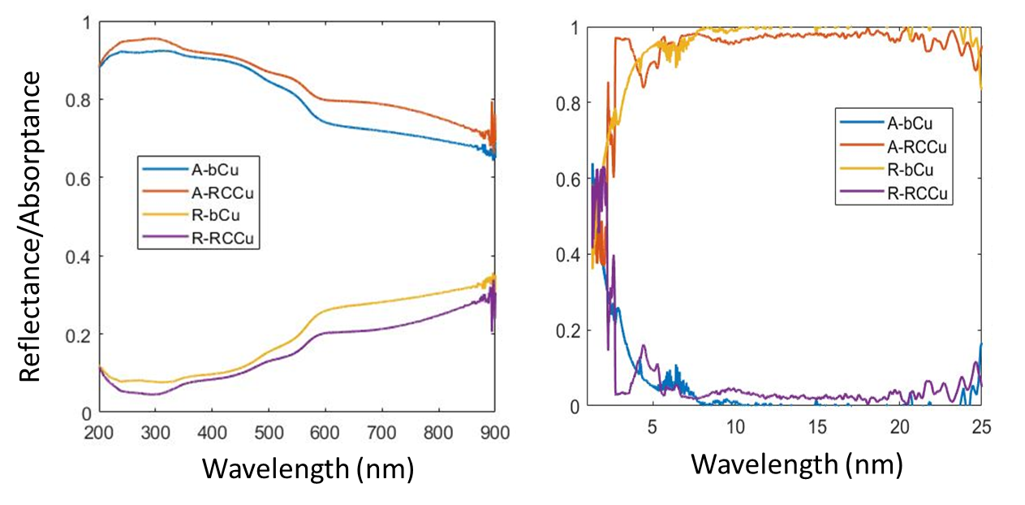
Figure S2. a) UV-Vis and b) IR spectra of bare (b-Cu) and b) radiative coated copper slabs (RC-Cu).

From Fig. S2, it can be seen that the radiative coating is highly transparent in the visible wavelength range, preserving its high reflection, as stated in the paper. It is noteworthy that the covered slab will get a slightly higher amount of solar radiation during daylight hours, due to an antireflection effect caused by the patterned structure. Using the values of absorption obtained by UV-Vis spectroscopy, the absorbed solar radiation power can be determined for each sample. The solar power absorbed by the bare copper surface is 460.5 W/m² while the coated slab absorbs 487.1W/m² , a difference of only 26.6 W/m². Thus, the slab covered with the radiative coating will heat up a little more compared to the bare slab due to this difference in absorbed solar radiation. Since the difference is small, the effect is expected to be lower than the cooling due to the increase in the radiated heat. From Fig.S2b), it can be clearly seen that the absorption of the copper slab with the radiative coating is close to unity beyond 5μm and that the radiative coating changes the radiative properties of the copper surface in the mid-IR, from highly reflective to highly emitting. Thus, it is expected that the effect of the cooling due to the increase in the radiated heat is greater than the heating provoked by the slight increase in solar power absorbed by the surface, when exposed to the sunlight. To avoid the slight increase in solar heating the HPs can be covered with a coating that reflects sunlight very efficiently, while still being highly emitting in the IR.

G. Kirchhoff, Ann. Phys. 1860, 185, 275

