EVALUATION OF SOIL MOISTURE ESTIMATION TECHNIQUES BASED ON SENTINEL-1 OBSERVATIONS OVER WHEAT FIELDS
SUPPLEMENTARY MATERIALS
- Monthly ESA CCI values
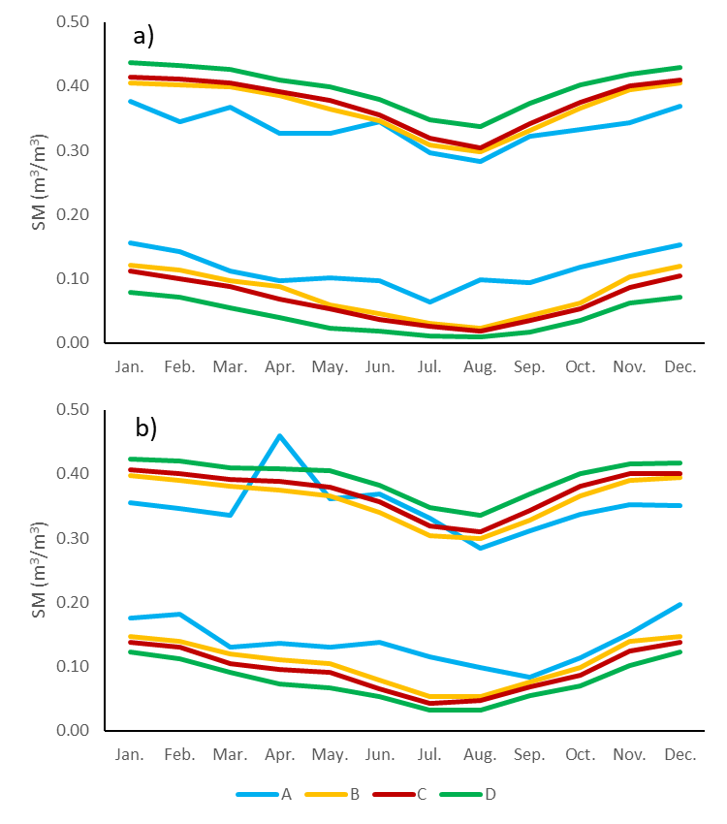
Figure S1. Monthly ESA CCI SM values for the different schemes considered. a) SM for fields 1, 2, 3, 4, 5 and 6; b) SM for fields 7 and 8.
- Calibration results
In this section, the results for the calibration of the different techniques are presented. The best schemes are selected for further comparison among methodologies.
  - Short Term Change Detection (STCD) approach
Figure S2 represents the calibration results for the STCD approach. Bars show RMSE and R values obtained after comparing SM_{est} with SM_{obs} for the different N values tested, different schemes for constraining maximum and minimum SM conditions and for the two backscatter time series: γ⁰_{CAN} and γ⁰_{SOIL}. Obtained RMSE values ranged between 0.09 and 0.12, and R values between 0.15 and 0.45. Best results were obtained for short N values (N=4 observations), since for longer values RMSE increased, and R mostly decreased, although the behavior of R was not as consistent. Regarding the schemes tested for constraining maximum and minimum SM conditions, scheme A (max and min values in the ESA CCI SM time series) produced the highest RMSE values and the lowest correlations. Schemes B, C and D provided similar results in terms of RMSE, but in terms of R values better results were obtained as the considered maximum and minimum SM values were more extreme, with best results for scheme D. In most cases, γ⁰_{SOIL} produces better results than γ⁰_{CAN}, but differences were not very significant.
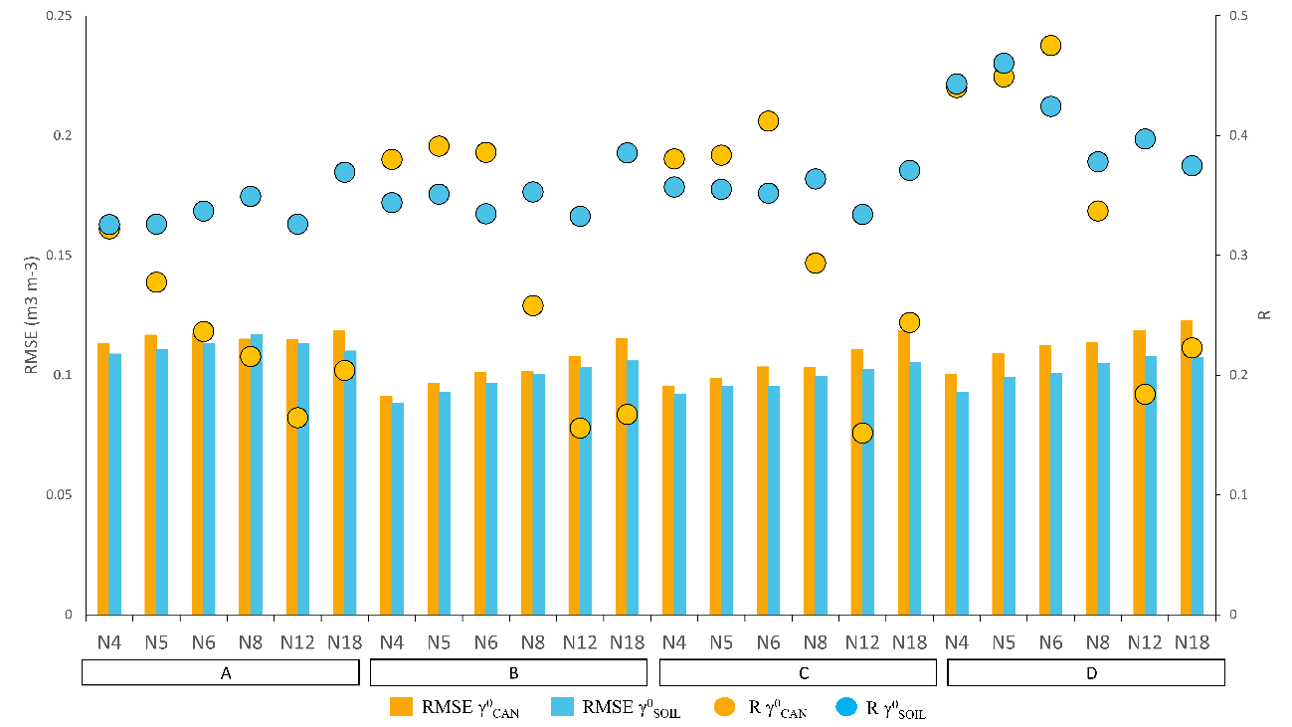
Fig. S2. Median RMSE and Correlation values between θ_{real and} θ_{est} for the STCD approach calibration schemes (A, B, C, D).
Considering both the RMSE and R results, scheme D and N=4 was chosen as the best option with almost the same results for γ⁰_{SOIL} and γ⁰_{CAN}.
  - TU Wien Change Detection (TUWCD) Model
Figure S3 shows the RMSE and R values obtained for the different schemes tested when implementing the TU Wien Change Detection Model. In this case, results improved clearly when applying the method to vegetation corrected γ⁰_{SOIL} time series, with RMSE values of 0.083-0.189 m³/m³ and R values of ~0.45. With no vegetation correction (γ⁰_{CAN}), RMSE values increased to 0.101-0.173 m³/m³ and correlation coefficients clearly decreased to ~0.20. Regarding the different schemes tested, optimum results were obtained for scheme 3, where the lower boundary ($γ_{min}^{0}$) corresponded to the absolute minimum, and the lower boundary ($γ_{max}^{0}$) to the 0.99 percentile. Results worsened when considering narrower higher percentiles for the minimum.

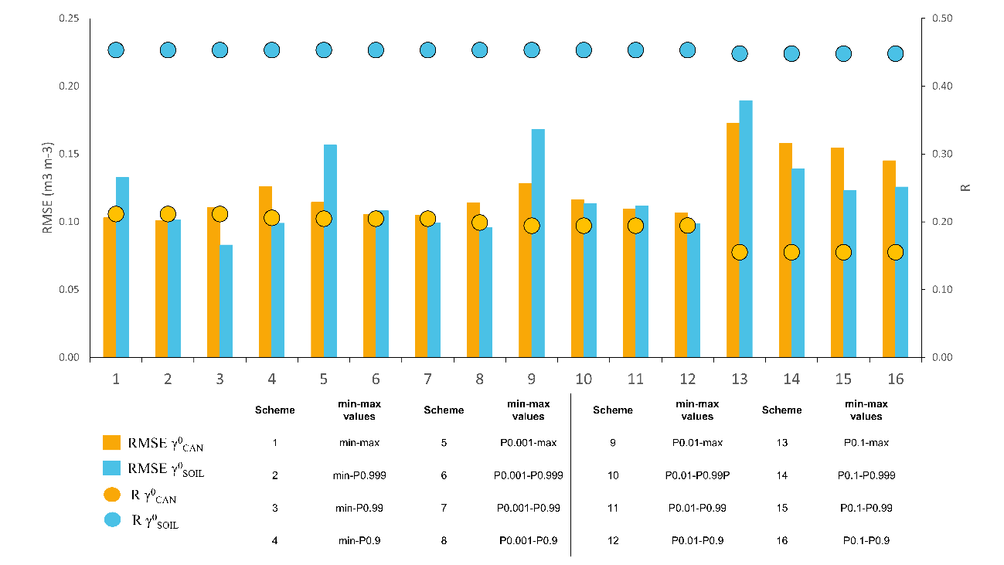
Fig. S3. Median RMSE and Correlation values between θ_{real and} θ_{est} for the Change Detection calibration schemes (1-16).
  - Multitemporal Bayesian change detection (MTBCD) approach
The optimization results for the roughness parameters s and l are presented in Figure S4. Low RMSE values (̴ 2dB) were obtained with different combinations of s and l for γ⁰_{SOIL}. However, for higher s values, the number of (s,l) pairs with RMSE below 3 dB decreased. The lowest RMSE (2.17 dB) was achieved with s=0.4 and l=3, therefore, this set of roughness parameters was used for the implementation of the Multitemporal Bayesian approach, even though it still represents a relevant difference between measured and estimated values. This may have an impact on the retrieved variables. The RMSE values between γ⁰_{CAN} and the IEM were worse, with higher minimum values (̴ 3dB).
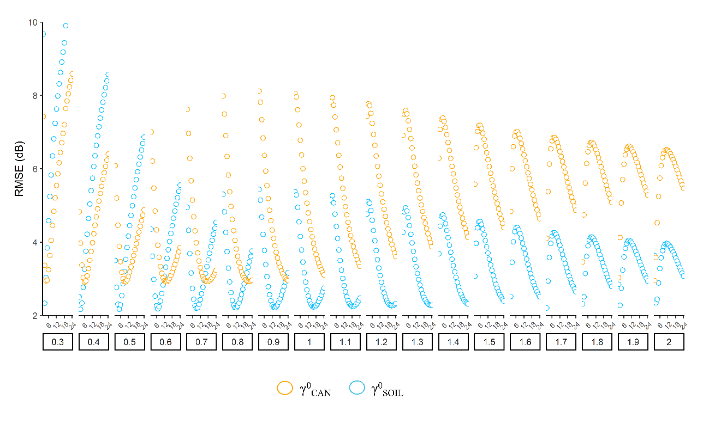
Fig. S4. RMSE between γ⁰_{CAN} and γ⁰_{SOIL} backscatter time series and IEM simulated time series for all wheat fields and every combination of roughness parameters (s and l).

- Comparison between methodologies
Table S1. RMSE results for the different SM estimation techniques
Field | Orbit Pass | RMSE (m³/m³)
 |  | STCD γ⁰_{CAN} | STCD γ⁰_{SOIL} | TUWCD γ⁰_{CAN} | TUWCD γ⁰_{SOIL} | MTBCD γ⁰_{CAN} | MTBCD γ⁰_{SOIL}
1 | 8DESC | 0.116 | 0.114 | 0.154 | 0.165 | 0.119 | 0.115
1 | 81DESC | 0.116 | 0.113 | 0.119 | 0.134 | 0.129 | 0.123
1 | 103ASC | 0.098 | 0.106 | 0.121 | 0.134 | 0.109 | 0.114
2 | 8DESC | 0.095 | 0.091 | 0.141 | 0.104 | 0.159 | 0.096
2 | 81DESC | 0.091 | 0.084 | 0.128 | 0.113 | 0.136 | 0.119
2 | 103ASC | 0.103 | 0.092 | 0.143 | 0.100 | 0.151 | 0.120
3 | 8DESC | 0.064 | 0.063 | 0.055 | 0.056 | 0.106 | 0.103
3 | 81DESC | 0.070 | 0.069 | 0.055 | 0.052 | 0.072 | 0.078
3 | 103ASC | 0.085 | 0.076 | 0.065 | 0.060 | 0.099 | 0.052
4 | 8DESC | 0.078 | 0.079 | 0.133 | 0.075 | 0.178 | 0.146
4 | 81DESC | 0.067 | 0.072 | 0.137 | 0.066 | 0.124 | 0.088
4 | 103ASC | 0.122 | 0.073 | 0.147 | 0.075 | 0.147 | 0.115
5 | 8DESC | 0.122 | 0.122 | 0.073 | 0.050 | 0.085 | 0.122
5 | 81DESC | 0.118 | 0.118 | 0.077 | 0.065 | 0.077 | 0.074
5 | 103ASC | 0.123 | 0.125 | 0.077 | 0.054 | 0.094 | 0.088
6 | 8DESC | 0.107 | 0.108 | 0.059 | 0.062 | 0.063 | 0.119
6 | 81DESC | 0.096 | 0.093 | 0.062 | 0.069 | 0.073 | 0.081
6 | 103ASC | 0.104 | 0.103 | 0.074 | 0.059 | 0.077 | 0.089
7 | 8DESC | 0.131 | 0.144 | 0.112 | 0.154 | 0.117 | 0.105
7 | 81DESC | 0.134 | 0.147 | 0.109 | 0.165 | 0.125 | 0.165
7 | 103ASC | 0.128 | 0.141 | 0.106 | 0.137 | 0.128 | 0.142
8 | 8DESC | 0.081 | 0.081 | 0.120 | 0.137 | 0.132 | 0.097
8 | 81DESC | 0.084 | 0.090 | 0.115 | 0.132 | 0.138 | 0.140
8 | 103ASC | 0.092 | 0.092 | 0.100 | 0.091 | 0.130 | 0.091

Table S2. BIAS results for the different SM estimation techniques
Field | Orbit Pass | BIAS (m³/m³)
 |  | STCD γ⁰_{CAN} | STCD γ⁰_{SOIL} | TUWCD γ⁰_{CAN} | TUWCD γ⁰_{SOIL} | MTBCD γ⁰_{CAN} | MTBCD γ⁰_{SOIL}
1 | 8DESC | 0.045 | 0.041 | 0.099 | 0.119 | 0.049 | 0.033
1 | 81DESC | 0.034 | 0.034 | 0.054 | 0.095 | 0.089 | 0.092
1 | 103ASC | 0.017 | 0.013 | 0.059 | 0.070 | 0.057 | 0.018
2 | 8DESC | -0.028 | -0.026 | 0.001 | 0.044 | -0.048 | -0.028
2 | 81DESC | -0.020 | -0.018 | -0.026 | 0.054 | 0.004 | 0.062
2 | 103ASC | -0.035 | -0.033 | -0.063 | 0.004 | -0.077 | -0.057
3 | 8DESC | -0.020 | -0.016 | 0.013 | 0.031 | -0.089 | -0.090
3 | 81DESC | -0.028 | -0.025 | -0.002 | 0.012 | -0.018 | -0.057
3 | 103ASC | -0.058 | -0.045 | -0.003 | 0.038 | -0.042 | -0.023
4 | 8DESC | -0.014 | -0.023 | -0.095 | -0.041 | -0.157 | -0.133
4 | 81DESC | -0.051 | -0.047 | -0.118 | -0.042 | -0.104 | -0.077
4 | 103ASC | -0.072 | -0.056 | -0.101 | -0.050 | -0.102 | -0.104
5 | 8DESC | -0.107 | -0.108 | 0.022 | 0.006 | -0.022 | -0.108
5 | 81DESC | -0.101 | -0.100 | 0.023 | 0.021 | 0.014 | -0.044
5 | 103ASC | -0.106 | -0.108 | -0.004 | 0.015 | -0.020 | -0.070
6 | 8DESC | -0.091 | -0.092 | -0.030 | -0.046 | -0.016 | -0.109
6 | 81DESC | -0.077 | -0.075 | -0.015 | -0.038 | 0.038 | -0.058
6 | 103ASC | -0.089 | -0.090 | -0.040 | -0.035 | 0.004 | -0.073
7 | 8DESC | 0.066 | 0.079 | 0.058 | 0.107 | 0.068 | 0.011
7 | 81DESC | 0.051 | 0.065 | 0.059 | 0.110 | 0.094 | 0.117
7 | 103ASC | 0.050 | 0.063 | 0.062 | 0.073 | 0.100 | 0.097
8 | 8DESC | 0.014 | 0.018 | 0.032 | 0.103 | 0.031 | 0.017
8 | 81DESC | 0.002 | 0.011 | 0.036 | 0.093 | 0.064 | 0.102
8 | 103ASC | 0.022 | 0.031 | 0.041 | 0.043 | 0.072 | 0.047

Table S3. ubRMSE results for the different SM estimation techniques
Field | Orbit Pass | ubRMSE (m³/m³)
 |  | STCD γ⁰_{CAN} | STCD γ⁰_{SOIL} | TUWCD γ⁰_{CAN} | TUWCD γ⁰_{SOIL} | MTBCD γ⁰_{CAN} | MTBCD γ⁰_{SOIL}
1 | 8DESC | 0.107 | 0.106 | 0.118 | 0.114 | 0.108 | 0.111
1 | 81DESC | 0.111 | 0.108 | 0.106 | 0.095 | 0.094 | 0.082
1 | 103ASC | 0.096 | 0.105 | 0.106 | 0.114 | 0.093 | 0.112
2 | 8DESC | 0.091 | 0.087 | 0.141 | 0.095 | 0.151 | 0.092
2 | 81DESC | 0.088 | 0.082 | 0.126 | 0.099 | 0.136 | 0.102
2 | 103ASC | 0.097 | 0.086 | 0.128 | 0.100 | 0.130 | 0.105
3 | 8DESC | 0.061 | 0.061 | 0.053 | 0.046 | 0.058 | 0.049
3 | 81DESC | 0.063 | 0.064 | 0.055 | 0.051 | 0.070 | 0.053
3 | 103ASC | 0.062 | 0.061 | 0.065 | 0.047 | 0.090 | 0.046
4 | 8DESC | 0.076 | 0.076 | 0.094 | 0.062 | 0.084 | 0.060
4 | 81DESC | 0.044 | 0.054 | 0.070 | 0.051 | 0.067 | 0.042
4 | 103ASC | 0.099 | 0.046 | 0.108 | 0.055 | 0.106 | 0.048
5 | 8DESC | 0.059 | 0.056 | 0.069 | 0.049 | 0.083 | 0.055
5 | 81DESC | 0.061 | 0.061 | 0.074 | 0.061 | 0.075 | 0.060
5 | 103ASC | 0.063 | 0.063 | 0.077 | 0.052 | 0.092 | 0.053
6 | 8DESC | 0.056 | 0.056 | 0.051 | 0.042 | 0.061 | 0.047
6 | 81DESC | 0.057 | 0.055 | 0.060 | 0.057 | 0.063 | 0.056
6 | 103ASC | 0.053 | 0.052 | 0.062 | 0.048 | 0.077 | 0.052
7 | 8DESC | 0.114 | 0.120 | 0.095 | 0.111 | 0.095 | 0.104
7 | 81DESC | 0.124 | 0.132 | 0.092 | 0.123 | 0.082 | 0.117
7 | 103ASC | 0.118 | 0.126 | 0.087 | 0.116 | 0.079 | 0.104
8 | 8DESC | 0.079 | 0.079 | 0.116 | 0.090 | 0.128 | 0.096
8 | 81DESC | 0.083 | 0.089 | 0.109 | 0.094 | 0.122 | 0.096
8 | 103ASC | 0.089 | 0.087 | 0.091 | 0.080 | 0.108 | 0.077

Table S4. Correlation results for the different SM estimation techniques
Field | Orbit Pass | R
 |  | STCD γ⁰_{CAN} | STCD γ⁰_{SOIL} | TUWCD γ⁰_{CAN} | TUWCD γ⁰_{SOIL} | MTBCD γ⁰_{CAN} | MTBCD γ⁰_{SOIL}
1 | 8DESC | 0.618 | 0.639 | 0.468 | 0.539 | 0.591 | 0.630
1 | 81DESC | 0.675 | 0.748 | 0.665 | 0.797 | 0.752 | 0.843
1 | 103ASC | 0.764 | 0.712 | 0.606 | 0.660 | 0.718 | 0.718
2 | 8DESC | 0.658 | 0.719 | -0.291 | 0.645 | -0.432 | 0.665
2 | 81DESC | 0.779 | 0.826 | 0.135 | 0.623 | 0.030 | 0.553
2 | 103ASC | 0.594 | 0.735 | 0.055 | 0.734 | 0.035 | 0.604
3 | 8DESC | 0.183 | 0.197 | 0.140 | 0.350 | 0.039 | 0.215
3 | 81DESC | 0.160 | 0.100 | 0.303 | 0.304 | 0.114 | 0.223
3 | 103ASC | -0.128 | 0.024 | -0.078 | 0.121 | -0.077 | 0.310
4 | 8DESC | 0.178 | 0.182 | -0.065 | 0.348 | -0.171 | 0.291
4 | 81DESC | 0.671 | 0.534 | 0.175 | 0.404 | 0.236 | 0.784
4 | 103ASC | 0.039 | 0.484 | 0.019 | -0.053 | 0.007 | 0.423
5 | 8DESC | 0.417 | 0.429 | 0.063 | 0.470 | -0.016 | 0.358
5 | 81DESC | 0.310 | 0.315 | 0.090 | 0.156 | 0.188 | 0.273
5 | 103ASC | 0.281 | 0.259 | -0.081 | 0.437 | -0.107 | 0.362
6 | 8DESC | 0.615 | 0.603 | 0.497 | 0.693 | 0.425 | 0.594
6 | 81DESC | 0.589 | 0.605 | 0.440 | 0.477 | 0.441 | 0.521
6 | 103ASC | 0.624 | 0.634 | 0.323 | 0.718 | 0.197 | 0.576
7 | 8DESC | 0.367 | 0.251 | 0.631 | 0.488 | 0.671 | 0.580
7 | 81DESC | 0.345 | 0.225 | 0.716 | 0.367 | 0.784 | 0.489
7 | 103ASC | 0.360 | 0.168 | 0.760 | 0.496 | 0.779 | 0.603
8 | 8DESC | 0.473 | 0.457 | 0.127 | 0.099 | 0.147 | 0.049
8 | 81DESC | 0.463 | 0.381 | 0.248 | 0.117 | 0.254 | 0.119
8 | 103ASC | 0.223 | 0.257 | 0.325 | 0.407 | 0.324 | 0.510

