Supporting Information
Magnetically recyclable TiO₂/MXene/MnFe₂O₄ photocatalyst for enhanced peroxymonosulphate-assisted photocatalytic degradation of carbamazepine
and ibuprofen under simulated solar light
Anna Grzegórska¹*, Joseph Chibueze Ofoegbu², Laura Cervera-Gabalda³, Cristina Gómez-Polo³, Diana Sannino², Anna Zielińska-Jurek¹*

¹ Department of Process Engineering and Chemical Technology, Faculty of Chemistry, Gdańsk University of Technology, G. Narutowicza 11/12, 80-233 Gdańsk, Poland
² Department of Industrial Engineering, University of Salerno, via Giovanni Paolo II, 132, 84084 Fisciano, Italy
³ Departamento de Ciencias-INAMAT², Universidad Pública de Navarra, Campus de Arrosadia, 31006 Pamplona, Spain
* Corresponding authors: annjurek@pg.edu.pl, anna.grzegorska@pg.edu.pl
- Results and discussion
3.1 Characterization of MnFe₂O₄, TiO₂/Ti₃C₂ and TiO₂/Ti₃C₂/MnFe₂O₄ photocatalysts
Table S1. ICP-OES measurements for the TiO₂/Ti₃C₂/5%MnFe₂O₄.
Element | Content (wt%)
Ti | 33.9930±2.0554
Mn | 0.9436±0.0632
Fe | 2.0062±0.1147

Figure S1. SEM area EDS spectrum with atomic and weight percentage of elements.
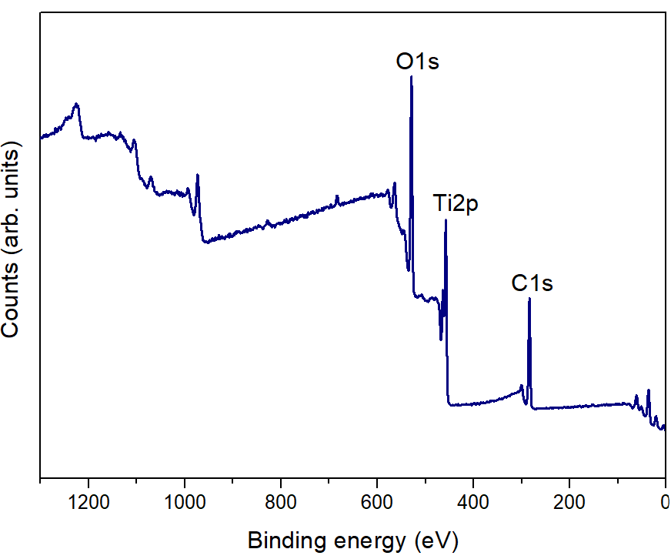
Figure S2. Survey XPS spectra for TiO₂/Ti₃C₂ composite.

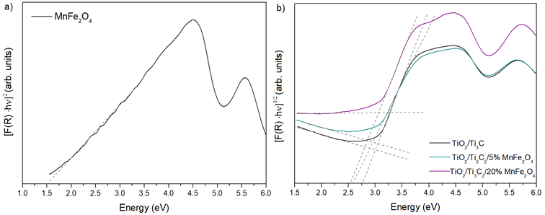
Figure S3. The band gap determination from Kubelka Munk function for various photocatalysts.
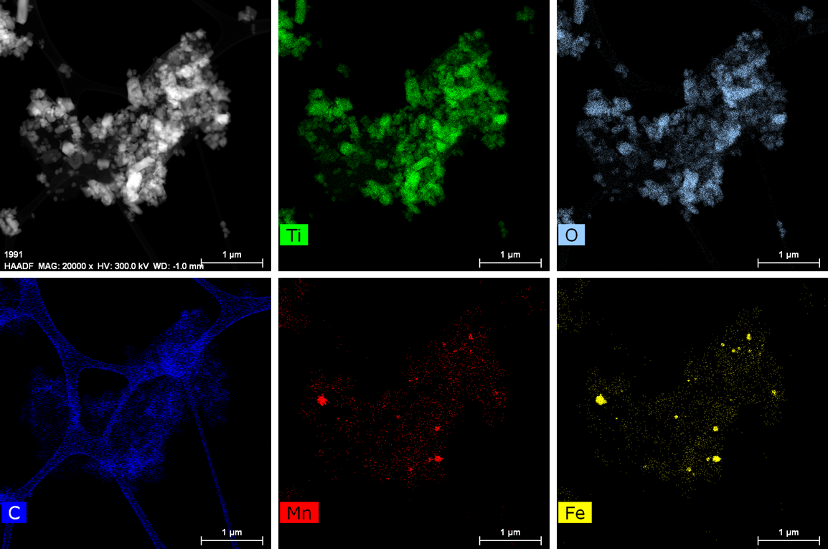
Figure S4. HAADF-STEM image and STEM-EDS elemental mapping of TiO₂/Ti₃C₂/5%MnFe₂O₄.

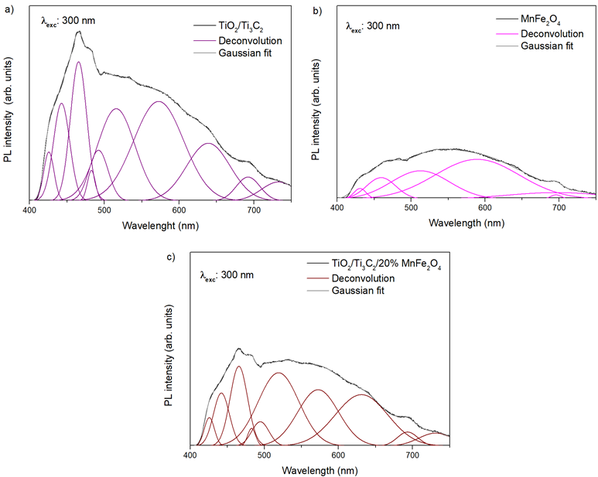
Figure S5. The Gaussian fitting and deconvolution of PL spectra of the TiO₂/Ti₃C₂ (a), MnFe₂O₄ (b), and TiO₂/Ti₃C₂/20%MnFe₂O₄ (c)

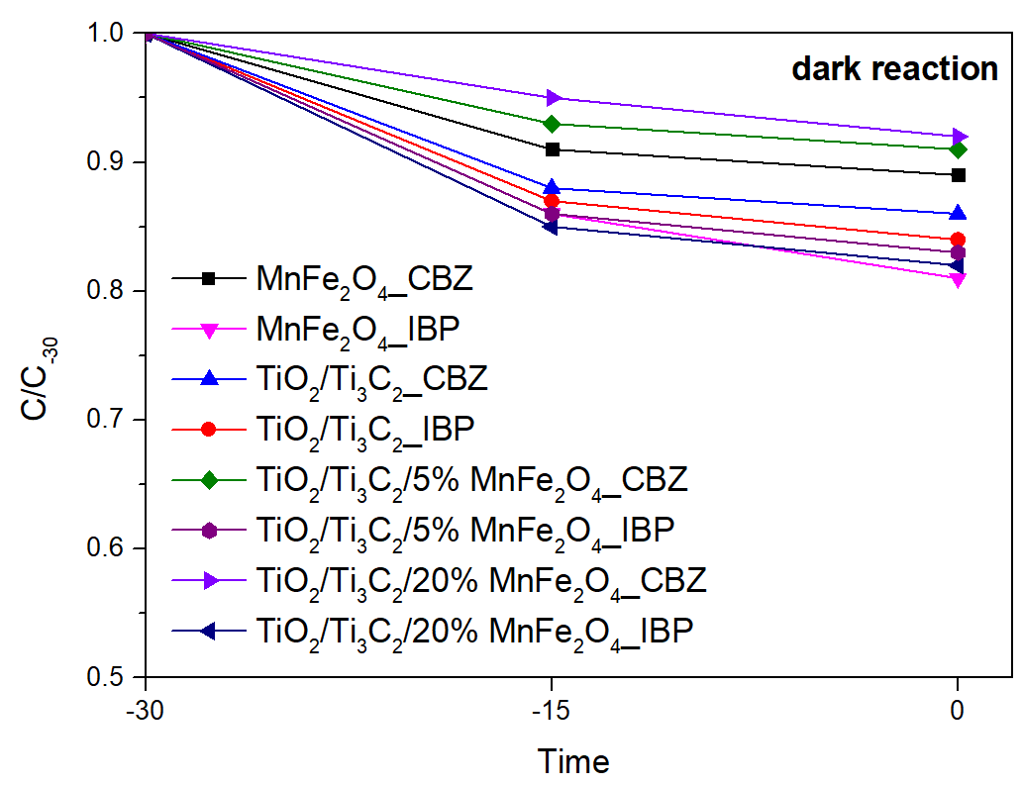
Figure S6. CBZ and IBP adsorption (dark reaction) for prepared materials.

Table S2. The rate constant of CBZ and IBP degradation in the CBZ/IBU mixture for selected processes.
Sample | CBZ degradation rate constant  (min⁻¹‧ 10⁻²) | IBP degradation rate constant  (min⁻¹‧ 10⁻²)
Photolysis | 0.5±0.02 | 1.2±0.05
Photolysis/PMS | 4.8±0.14 | 5.2±0.23
TiO₂/Ti₃C₂ | 6.9±0.19 | 6.2±0.24
TiO₂/Ti₃C₂/5% MnFe₂O₄ | 8.9±0.27 | 7.0±0.18
TiO₂/Ti₃C₂/5% MnFe₂O₄ /PMS (0.25 mM) | 28.6±0.98 | 53.0±1.4

Table S3. The TOC removal (%) in the CBZ/IBU mixture for selected processes.
Sample | TOC removal (%)
TiO₂/Ti₃C₂/5% MnFe₂O₄ /PMS (0.25 mM) Amount of photocatalyts - 2g/dm³ | 54±1.7%
TiO₂/Ti₃C₂/5% MnFe₂O₄ /PMS (0.25 mM) Amount of photocatalyts - 1g/dm³ | 51±0.6%
TiO₂/Ti₃C₂/5% MnFe₂O₄ /PMS (0.25 mM) Amount of photocatalyts - 0.5 g/dm³ | 47±1.3%
TiO₂/Ti₃C₂/5% MnFe₂O₄ /PMS (0.25 mM) pH 4.5 | 57±0.8%
TiO₂/Ti₃C₂/5% MnFe₂O₄ /PMS (0.25 mM) pH 9.5 | 43.1±1.1%
TiO₂/Ti₃C₂/5% MnFe₂O₄ /PMS (0.25 mM) Seawater | 60.3±2.1%
Table S4. The metal lixiviation results for a post-process solution using TiO₂/Ti₃C₂/5% MnFe₂O₄/PMS (0.25 mM) and amount of photocatalyst – 2 g/dm³.
Element | ICP-OES  (mg/dm³) | Iron Photometric Test  (mg/dm³)
Ti | <LOD | -
Mn | 0.423±0.032 | -
Fe | 0.089±0.010 | 0.08

