**From Fundamental Materials Chemistry to Sensing Applications: Unravelling the Water Adsorption Mechanism of a Luminescent Optical Fibre Sensor Membrane**

Guillermo Cruz-Quesadaa, Beatriz Rosales-Reinaa, Diego López-Torresb, Santiago Reinosoa, María Victoria López-Ramónc, Gurutze Arzamendia, César Elosua*b, Maialen Espinal-Viguri*a, and Julián J. Garrido*a

a Institute for Advanced Materials and Mathematics (INAMAT2) & Departamento de Ciencias, Public University of Navarre (UPNA), Campus de Arrosadía, 31006 Pamplona, Spain

b Institute of Smart Cities (ISC) & Departamento de Ingeniería Eléctrica, Electrónica y de Comunicación, Public University of Navarre (UPNA), Campus de Arrosadía, 31006 Pamplona, Spain

c Departamento de Química Inorgánica y Orgánica; Facultad de Ciencias Experimentales, University of Jaén, 23071 Jaén, Spain

**Supplementary Material**

|  |  |
| --- | --- |
| **S1. Experimental**……………………………………………………………………………………….. | **3** |
| **S1.1.** Materials…………………………………………………………………………………………... | 3 |
| **S1.2.** Characterisation methods of the Ln-AL materials………………………………………................ | 3 |
| **S1.3.** Sensing mechanism and photonic experimental set-up……………………………………………. | 4 |
| ***Fig. S1.*** *Experimental set-up to register the sensor response*………………………………………….. | 5 |
| **S2. Results and discussion: Supplementary figures and tables**……………………………………... | **6** |
| ***Fig. S2.*** *Luminescent emission of the synthesised Ln-AL materials*….………………………………… | 6 |
| ***Table S1.*** *Textural parameters from adsorption isotherms for Ln-AL xerogels and TEOS references…* | 6 |
| ***Fig. S3****. Semilogarithmic scale representation of N2 adsorption isotherms of Ln-AL xerogels………….* | 7 |
| ***Fig. S4****. Semilogarithmic scale representation of CO2 adsorption isotherms of Ln-AL xerogels………..* | 7 |
| ***Fig. S5****. SEM micrographs of TEOS-4.5, Eu-PB, and Tb-PB* …………..……………………………… | 7 |
| ***Fig. S6.*** *EDX mapping of Eu-PB and Tb-PB materials containing 3 % in weight of Ln*.……………… | 8 |
| ***Fig. S7.*** *PXRD patterns of TEOS-4.5, Eu-PB, and Tb-PB……………*……...………………………….. | 8 |
| ***Fig. S8****. FT-IR spectra (ranges 2800-4000 and 400-1800 cm-1) of TEOS-4.5, Eu-PB, and Tb-PB……..* | 9 |
| ***Table S2.*** *Assignment of FT-IR bands in the spectra of TEOS-4.5, Eu-PB, and Tb-PB………………….* | 9 |
| ***Fig. S9.*** *Third-grade polynomial fitting for OFSTb-PB calibration curves………………………………..* | 10 |
| ***Table S3****. Fitting parameters of OFSTb-PB calibration curves to a third-grade polynomial equation...* | 10 |
| ***Fig. S10.*** *Semilogarithmic scale representation of H2O adsorption isotherms of Tb-PB monolith …….* | 11 |
| ***Fig. S11.*** *Polynomial fitting of the water-vapour adsorption isotherms for the Tb-PB monolith……….* | 11 |
| ***Table S4****. Fitting parameters of Tb-PB water-vapour isotherms to a polynomial equation………………* | 11 |
| **References**……………………………………………………………………………………... | **12** |

**S1. Experimental**

**S1.1. Materials**

Plastic-clad silica fibres with 1000 μm of inner diameter were purchased from Thorlabs. The chemicals purchased from commercial sources were used as received used without further purification. These are:

The siliceous tetraethoxysilane precursor (TEOS), supplied by Sigma-Aldrich (St. Louis, MO, USA) with a purity greater than 99%. Absolute ethanol (Emsure®) for analysis and hydrochloric acid (HCl, 37% w/w), purchased from Merck (Darmstadt, Germany). Hydrofluoric acid (HF, 48% w/w), obtained from Sigma-Aldrich. The europium salt Eu(NO3)3·6H2O (Eu purity > 99%), purchased from Alfa Aesar, Thermo Fisher Scientific (Ward Hill, Massachusetts, USA). The terbium salt Tb(NO3)3·6H2O (Tb purity > 99.9%), purchased from Strem Chemicals, INC (Newburyport, Massachusetts, USA). The chelating ligands CA (Chelidamic Acid, > 99 %), 3OHPA ((3-hydroxy)-pyridine-2-carboxylic acid, > 98%), 3MPA (3-methyl-pyridine-2-carboxylic acid, > 97%), 6FPA (6-(trifluoromethyl)-pyridine-2-carboxylic acid, > 97%) and DPA (2, 6- pyridine carboxylic acid, > 99%), supplied by Sigma-Aldrich (San Luis, MO, USA). The chelating ligands 6OHPA ((6-hydroxy)-pyridine-2-carboxylic acid, > 95%) and 3APC (3-amino-pyridine-2-carboxylic acid, > 97%), supplied by Across Organics, Thermo Fisher Scientific (Ward Hill, Massachusetts, USA).

The non-commercial antenna ligand PB (2,2′-(4-(2-Ethoxyethoxy)pyridine-2,6-diyl)bis(4,5-dihydrooxazole)) was synthesised following the procedure described in the literature [1].

**S1.2. Characterization methods of the Ln-AL materials**

UV-VIS excitation and emission spectra of the xerogels were recorded using a Horiba Fluorolog spectrofluorometer (Horiba, Kyoto, Japan). The spectra were recorded in the range 300-700 and 250-600 nm for the materials synthesised with EuIII and TbIII, respectively. The operation parameters were: 0.1 s integration time; 1 nm increment; 1 nm of “Side Entrance” or 2 nm of “Exit Slit” for the excitation and emission spectra, respectively.

The structure of the xerogels was studied using infrared spectroscopy and powder X-ray diffraction. Infrared spectra were recorded on KBr pellets using a Jasco 4700 FT-IR spectrometer (Jasco, Tokyo, Japan) at 25 scans and a resolution of 4 cm−1. The KBr pellets were prepared with two sample concentrations: (i) 0.6 mg of sample in 200 mg of KBr tablet for the spectra in the range 2200–400 cm−1 [2]; and (ii) 2 mg of sample in 200 mg of KBr for the spectra in the range 4000–2200 cm−1. The pellets were dried overnight in an oven at 373 K under a vacuum to remove adsorbed water before the spectra acquisition. X-ray diffraction patterns were obtained at room temperature using a Bruker D8-Advance powder XRD instrument (Bruker, USA) equipped with copper rotating anode and graphite monochromator (at 45 kV and 40 mA) to select the CuKα1/2 wavelength at 0.154 nm. Measurements were performed in a stepped scan mode of 2 ≤ 2θ ≤ 50o in steps of 0.013o at a rate of 0.5 steps·s−1 [3].

The textural properties of the materials were studied through adsorption isotherms obtained with a Micrometrics ASAP2020 volumetric adsorption system (Micromeritics, Norcross, GA, USA) using three different adsorbates (N2, CO2 and H2O(v)). To perform the measurements, approximately 150 mg of sample was weighed in a straight-walled Pyrex glass tube followed by degassing at 423 K for 3-6 hours with a residual vacuum of < 0.66 Pa depending on the equilibrium time.

For N2 adsorption isotherms (77 K) the tubes were coated with an isothermal jacket and immersed in liquid N2 (77 K) inside a Dewar vessel. The recorded adsorption data were analysed with the Microactive software (version 4.06), adjusting the appropriate parameters for each model. Specific surface areas (aBET) were calculated using the Brunauer–Emmett–Teller (BET) model and the Rouquerol criteria [4], while the characteristic adsorption energy (Ec(N2)) and micropore volume (Vmicro(N2)) were calculated using the Dubinin-Radushkevich (DR) method [5]. The liquid density of N2 to calculate the pore volumes was obtained from the literature (0.808 g·cm−3) [6]. The total pore volume (VTotal) was abstracted from the isotherm at p/p0 = 0.95, while the mesopore volume (Vmeso) was calculated as the volume difference between p/p0 = 0.95 and 0.8

To obtain the CO2 adsorption isotherms, the tube was placed in a thermostatised recirculation bath (PolyScience, Niles, IL, USA) at 273 K, using a 50% water-ethylene glycol mixture as a refrigerant. The DR method was used to obtain the volume of micropores, the equivalent surface area (aDR(CO2)), characteristic adsorption energy (Ec(CO2)) and volume of micropores (Vmicro(CO2)) with pore width  ≤ 0.7 nm. A cross-sectional area (σ) of 0.17 nm2 and an affinity coefficient (β) of 0.461 [7] were applied in the calculations. The liquid density of CO2 was obtained from the literature (1.023 g·cm−3) [8].

Additionally, H2O(v) adsorption isotherms at three different temperatures (298 K, 303 K, and 308 K) were obtained by placing the sample tubes in a thermostatised bath and providing the water with a vapour kit equipment. The model BET was used to analyse the data, and the volume pore criteria were the same as for the N2 adsorption. The liquid density of H2O was obtained from the literature and set to 0.997 g.cm−3 [9].

The pore size distributions (PSD) were determined according to density-functional theory (DFT) using the SAIEUS method and software [10]. The models “Carbon-N2-77, 2D-NLDFT Heterogeneous Surface” and “Carbon-CO2-273, 2D-NLDFT Het Surface, pp max = 10 atm” were applied for the N2 and CO2 adsorptions, respectively. For the H2O adsorption isotherms, the cylindrical pore equivalent model and the parallel plate pore model were used.

The morphology of the Ln-AL materials and distribution of the lanthanides within the XG matrices were studied using Scanning Electron Microscopy (SEM) and Energy-Dispersive X-ray Spectroscopy (EDX) techniques, respectively. Micrographs were obtained with a Zeiss EVO 15 emission scanning electron microscope (Zeiss, Oberkochen, Germany) and the surface distribution of elements with Zeiss SMART EDX at 5 kV. The thickness of the OFS membrane coating was determined for OFSTb-PB as follows: 3 layers of the doped XG matrix were deposited on a silicon wafer and the resulting film was scratched before analysing its profile with a Bruker Dektak XT profilometer.

**S1.3. Sensing mechanism and photonic experimental set-up**

The sensing mechanism is based on the change in the luminescent intensity emission when water vapour is adsorbed on the silica XG film covering the tip of the optical fibre. The water molecules diffuse through the coating and interact with the luminescent species entrapped in the silica matrix. The water adsorption-desorption process reversibly quenches the luminescent emission, thus, working as an on-and-off transduction mechanism for the sensor [11]. As lanthanides have several emission peaks, the one with the highest signal-to-noise ratio was used for the characterisation (545 nm for TbIII and 615 nm for EuIII, see **section 3.1**).

The intensity of the luminescent emission was affected by photobleaching, the effect of which was mathematically removed from the sensor response as it led to exponential decay. The sensor response was characterised by referencing the variation of intensity of the selected luminescence emission peak for each RH value (Δ*I* = *IRH–Iref)* to *Iref*, which is the intensity corresponding to the lowest RH value (20 %). The reference intensity *Iref* showed the highest level among all intensities registered, therefore the sign of the normalised intensity variations (Δ*I*/*Iref*) was reverted for the resulting values to be always positive, which eases its comparison with humidity dynamic changes (see **Eq. S1**). This approach matches the sensor behaviour better than other models [12] and has already been successfully proposed by other authors [13]. Finally, the resulting –Δ*I*/*Iref* values were represented against the water vapour molar concentration () instead of time to correlate the sensor calibration with the water vapour isotherms. The water vapour molar concentration values (mM) were calculated using **Eq. S2** to obtain the absolute humidity (W) and **Eq. S3**

where W is the absolute humidity, ϕ is a factor equal to 0.622 [14], RH is the relative humidity, Pw is the water vapour pressure at a given temperature, C is the water vapour molar concentration, Vdry air is de dry air volume, MWH2O is the molecular weight of water, and Vc.c is the climatic chamber volume [15].

A reflection setup (**Fig. S1**) based on a 600 μm bifurcated fibre (High OH Fiber bundle, BFY1000HS02, from ThorLabs Inc.) was used for characterizing both the sensor construction and its response. The diameter of the bifurcated fibre ensures the maximum signal coupling [16]. The optical fibre pigtail was connected to the common branch of the bifurcated fibre (**Fig. S1**. Point 3) with an SMA-SMA connector and the optical source (an LED centred at the excitation wavelength of the material, purchased from Pyroistech) and an LSL Maya spectrometer (obtained from Ocean Insight) to the other two branches, respectively. For the film deposition (detailed in **Fig. 2** in the main text) a dip-coating robot (ND DC 150 m by Nadetech Innovations) was used to control the immersion and extraction speeds. For analysing the response towards humidity and temperature, the sensor was placed in a climatic chamber (KMF-115 by Binder) and was evaluated by relative humidity cycles ranging from 20 to 90 % at three different temperatures (298, 303 and 308 K). Data were recorded using the Ocean View 2.0 software (Ocean Insight) installed on a PC using an integration time of 500 ms. The Limits of Detection (LoD) of the OFSTb-PB sensor were calculated using **Eq. S4** [17]

where *k*(signal) is a numerical value that depends on the level of reliability chosen (in our case, *k*(signal) = 3, corresponding to a reliability level of 99.86 %), B is the slope of the calibration curve in the linear region, and stdA is the standard deviation of the intercept of the linear fitting equation (see **Table 3** in the main text).

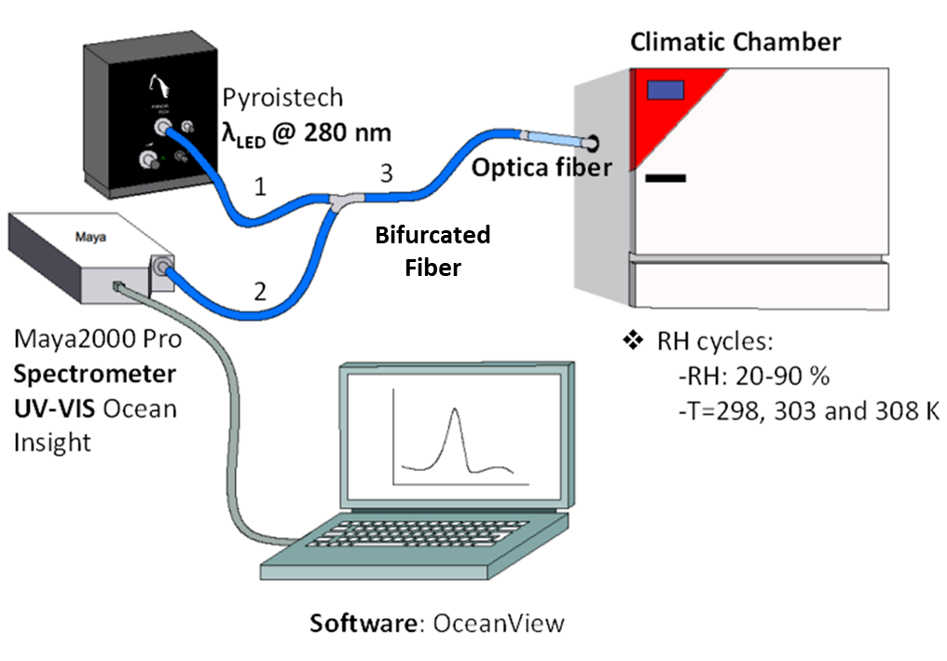

**Fig. S1.** Experimental set-up to register the sensor response.

**S2. Results and discussion: Supplementary figures and tables**



**(a)**

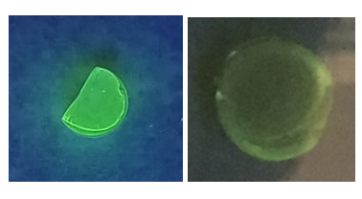

**(b)**

**Fig. S2**. (a)Luminescent emission of vacuum-dried (373 K) Ln-AL materials under UV lamp for thin layer chromatography (Vilber model CN-6 equipped with a VL-6.LC filtered UV lamp, Germany); (b) Luminescent emission of the vacuum-dried Tb-FPA monolith (left) compared to that of a moisturised counterpart (right).

**Table S1**. Textural parameters determined from the adsorption isotherms for Ln-AL materials and their TEOS references.

|  |  |  |  |  |  |  |  |  |  |  |  |  |  |  |
| --- | --- | --- | --- | --- | --- | --- | --- | --- | --- | --- | --- | --- | --- | --- |
| **Type** |  | **aBETa**  **N2** | **aDRb**  **CO2** |  | **Vmicroc**  **N2** | **Vmicroc**  **CO2** | **Vmesod**  **N2** | **Vtotale**  **N2** |  | **PSDf Maximum**  **N2 **ϕ **< 2 nm)** | **PSDf Maximum**  **CO2** |  | **Ecg**  **N2** | **Ecg**  **CO2** |
|  | m2·g-1 | |  | cm3·g-1 | | | |  | nm | |  | kJ·mol-1 | |
| **TEOS-4.5** |  | 697 | 510 |  | 0.29 | 0.19 | 0.12 | 0.41 |  | 0.95 | 0.59 |  | 15.5 | 19.9 |
| **Eu-PB** |  | 647 | 439 |  | 0.27 | 0.18 | 0.01 | 0.29 |  | 1.02 | 0.61 |  | 16.5 | 19.0 |
| **Tb-PB** |  | 569 | 379 |  | 0.23 | 0.16 | i | 0.23 |  | 0.91 | 0.59 |  | 22.2 | 19.0 |
| **TEOS-2.7** |  | 445 | 494 |  | 0.18 | 0.21 | 0.01 | 0.18 |  | 0.83 | 0.59 |  | 24.3 | 20.0 |
| **Eu-CA** |  | h | 502 |  | j | 0.21 | j | j |  | h | 0.56 |  | j | 20.2 |
| **Tb-CA** |  | h | 515 |  | j | 0.22 | j | 0.04 |  | 0.76 | 0.56 |  | j | 20.2 |
| aSpecific surface area obtained from the BET model; bSpecific surface area calculated by applying the DR method; cMicropore volume obtained from DR; dCalculated from the isotherm (Vmeso = Vtotal-Vmacro-Vmicro); eTotal pore volume obtained from the isotherm at p/p0 = 0.95; fPore size distribution calculated with DFT-based methods; gCharacteristic energy from DR; hSpecific surface area cannot be calculated using BET; iPore volume lower than 0.01 m2·g-1; jInsufficient data for applying DR | | | | | | | | | | | | | | |



**Fig. S3**. Semilogarithmic scale representation of the region of low relative pressures in the N2 adsorption isotherms of Ln-PB and Ln-CA materials and their TEOS-4.5 and TEOS-2.7 references.



**Fig. S4**. Semilogarithmic scale representation of the region of low relative pressures in the CO2 adsorption isotherms of Ln-PB and Ln-CA materials and their TEOS-4.5 and TEOS-2.7 references.



**Fig. S5**. SEM micrographs of TEOS-4.5, Eu-PB, and Tb-PB.



***Fig. S6.*** *EDX mapping of Eu-PB (top) and Tb-PB (bottom) materials containing 3 % in weight of Ln.*



**Fig. S7.** Powder X-ray diffraction patterns of Ln-PB materials compared to that of the TEOS-4.5 reference.



**Fig. S8**. Infrared spectra of Ln-PB materials and the TEOS-4.5 reference in the ranges 2800-4000 and 400-1800 cm-1 (range from 1800 to 2800 cm-1 not included due to the lack of any relevant band).

**Table S2.** Literature-based assignment of FT-IR bands (cm-1) in the spectra of Ln-PB materials and the TEOS-4.5 reference.

|  |  |  |  |  |
| --- | --- | --- | --- | --- |
| **TEOS-4.5** | **Eu-PB** | **Tb-PB** | **Assignment** | **Reference** |
| 3436 | 3449 | 3440 | ν (SiO-H) | [18] |
| - | - | 2983 | νas (C‐H), -CH3 | [19] |
| 2919 | - | - | νas (C‐H), -CH2- | [19] |
| 2851 | - | - | νs (C‐H), -CH2- | [19] |
| 1621 | 1637 | 1634 | *δ* H2O | [20] |
| - | 1384 | 1384 | νas (O2N-O) | [21] |
| 1091 | 1088 | 1086 | νas (Si-O-Si) | [22,23] |
| 948 | 946 | 944 | ν (Si-OH) | [24,25] |
| 800 | 796 | 796 | νs (O-Si-O) | [18,24] |
| 562 | 556 | 562 | ν Si-O, T4 | [26] |
| 463 | 461 | 457 | ρ (O-Si-O) | [27] |



**Fig. S9.** Fitting of the OFSTb-PB calibration curves at different working temperatures to third-grade polynomial equations (adsorption branch: dashed grey line; desorption branch: dotted black line).

**Table S3**. Fitting parameters of the OFSTb-PB calibration curves to third-grade polynomial equations (y = A + B1x + B2x2 + B3x3)

|  |  |  |  |  |  |  |  |  |  |  |  |
| --- | --- | --- | --- | --- | --- | --- | --- | --- | --- | --- | --- |
| **T\*** |  | **A** |  | **B1** |  | | **B2** |  | **B3** | **R2** | |
| **K** |  | **r.u** | | **(mM)-1** | | **(mM)-2** | | | **(mM)-3** |
| 298ads |  | -0.114±0.014 |  | 0.642±0.073 |  | | -0.947±0.120 |  | 0.540±0.062 |  | 0.987 |
| 298des |  | -0.040±0.005 |  | 0.192±0.031 |  | | -0.105±0.053 |  | 0.090±0.029 |  | 0.997 |
| 303ads |  | -0.110±0.012 |  | 0.555±0.053 |  | | -0.803±0.069 |  | 0.410±0.028 |  | 0.987 |
| 303des |  | -0.030±0.007 |  | 0.117±0.028 |  | | -0.073±0.036 |  | 0.085±0.015 |  | 0.998 |
| 308ads |  | -0.155±0.014 |  | 0.585±0.042 |  | | -0.651±0.040 |  | 0.252±0.012 |  | 0.995 |
| 308des |  | -0.030±0.007 |  | 0.076±0.021 |  | | 0.004±0.021 |  | 0.026±0.006 |  | 0.999 |

* ads: adsorption branch; des: desorption branch



***Fig. S10.*** *Semilogarithmic scale representation of water vapour adsorption isotherms of Tb-PB monolith*

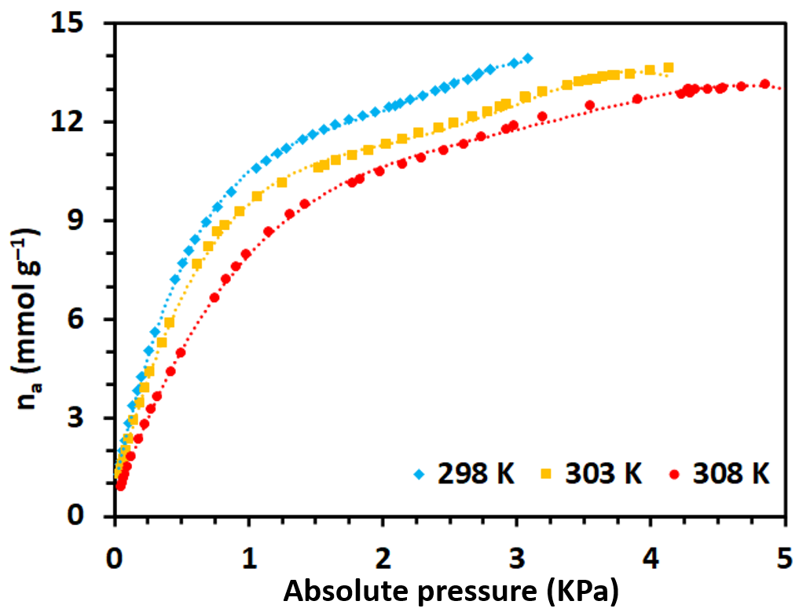

**Fig. S11.** Best-fitting of the water vapour adsorption isotherms for the Tb-PB monolith.

**Table S4**. Fitting parameters of the water vapour adsorption isotherms of Tb-PB to a fourth-grade polynomial equation (y = A + B1x + B2x2 + B3x3 + B4x4).

|  |  |  |  |  |  |  |  |
| --- | --- | --- | --- | --- | --- | --- | --- |
| **T** | **A** | **B1** | **B2** | **B3** | **B4** | **R2** | |
| **K** | **kPa** | **mmol·g (kPa)-1** | **mmol·g (kPa)-2** | **mmol·g (kPa)-3** | **mmol·g (kPa)-4** |
| 298ads | 0.893±0.030 | 18.932±0.182 | -13.106±0.263 | 4.265±0.133 | -0.507±0.022 | 0.999 |
| 303ads | 0.733±0.043 | 15.951±0.190 | -9.519±0.201 | 2.604±0.075 | -0.255±0.009 | 0.999 |
| 308ads | 0.398±0.040 | 11.586±0.146 | -4.987±0.129 | 1.040±0.040 | -0.081±0.004 | 0.999 |

**References**

[1] A. de Bettencourt-Dias, P.S. Barber, S. Bauer, A water-soluble Pybox derivative and its highly luminescent lanthanide ion complexes, J. Am. Chem. Soc. 134 (2012) 6987–6994. https://doi.org/10.1021/ja209572m.

[2] A. Fidalgo, R. Ciriminna, L.M. Ilharco, M. Pagliaro, Role of the alkyl-alkoxide precursor on the structure and catalytic properties of hybrid sol-gel catalysts, Chem. Mater. 17 (2005) 6686–6694. https://doi.org/10.1021/cm051954x.

[3] S. Sakka, Part II: Characterization, in: Handbook of Sol-Gel Science and Technology, Springer International Publishing, 2018, pp. 1119–1902. https://doi.org/10.1007/978-3-319-32101-1.

[4] F. Rouquerol, J. Rouquerol, K. Sing, Chapter 6-Assessment of Surface Area, in: Adsorption by Powders and Porous Solids: Principles, Methodology and Applications, 2nd ed., Academic Press, 1999, pp. 165–189. https://doi.org/10.1016/B978-0-12-598920-6.X5000-3.

[5] M.M. Dubinin, The potential theory of adsorption of gases and vapors for adsorbents with energetically nonuniform surfaces, Chem. Rev. 60 (1960) 235–241. https://doi.org/10.1021/cr60204a006.

[6] J. Garrido, A. Linares-Solano, J.M. Martin-Martinez, M. Molina-Sabio, F. Rodriguez-Reinoso, R. Torregrosa, Use of N2 vs. CO2 in the characterization of activated carbons, Langmuir 3 (1987) 76–81. https://doi.org/10.1021/la00073a013

[7] G. Lucovsky, Spectroscopic evidence for valence-alternation-pair defect states in vitreous SiO2, Philos. Mag. B 39 (1979) 513–530. https://doi.org/10.1080/13642817908246002.

[8] J. García-Martínez, D. Cazorla-Amorós, A. Linares-Solano, Further evidences of the usefulness of CO2 adsorption to characterize microporous solids, Stud. Surf. Sci. Catal. 128 (2000) 485–494. https://doi.org/10.1016/S0167-2991(00)80054-3.

[9] S. Duan, L. Geng, G. Li, X. Ling, Water vapour adsorption isotherms of shales: Thermodynamic properties and microstructure. Fluid Phase Equilib. 563 (2022) 113583. https://doi.org/10.1016/j.fluid.2022.113583.

[10] J. Jagiełło, Stable numerical solution of the adsorption integral equation using splines, Langmuir 10 (1994) 2778–2785. https://doi.org/10.1021/la00020a045.

[11] M.A. Omary, H.H. Patterson, Luminescence, Theory, in: Encyclopedia of Spectroscopy and Spectrometry, Elsevier, 2016, pp. 636–653. https://doi.org/10.1016/B978-0-12-803224-4.00193-X.

[12] M.L. Aguayo-López, L.F. Capitán-Vallvey, M.D. Fernández-Ramos, Optical sensor for carbon dioxide gas determination, characterization and improvements, Talanta 126 (2014) 196–201. https://doi.org/10.1016/j.talanta.2014.03.050

[13] X.-M. Li, K.-Y. Wong, Luminescent platinum complex in solid films for optical sensing of oxygen, Anal. Chim. Acta 262 (1992) 27–32. https://doi.org/10.1016/0003-2670(92)80004-Q

[14] R.P. Singh, D.R. Heldman, Psychrometrics, in: Introduction to Food Engineering, fifth ed., Academic Press, 2014, pp. 593–616. https://doi.org/10.1016/B978-0-12-398530-9.00009-7.

[15] J.C. Echeverría, I. Calleja, P. Moriones, J.J. Garrido, Fiber optic sensors based on hybrid phenyl-silica xerogel films to detect n-hexane: Determination of the isosteric enthalpy of adsorption, Beilstein J. Nanotechnol. 8 (2017) 475–484. https://doi.org/10.3762/bjnano.8.51.

[16] C. Elosua, N. De Acha, M. Hernaez, I.R. Matias, F.J. Arregui, Layer-by-Layer assembly of a water-insoluble platinum complex for optical fiber oxygen sensors, Sens. Actuators B Chem. 207 (2015) 683–689. https://doi.org/10.1016/j.snb.2014.10.042.

[17] IUPAC-Analytical Chemistry Division, Nomenclature, symbols, units and their usage in spectrochemical analysis-II. Data interpretation, Spectrochim. Acta, Part B 33 (1978) 242–248. https://doi.org/10.1016/0584-8547(78)80044-5.

[18] P. Innocenzi, Infrared spectroscopy of sol-gel derived silica-based films: a spectra-microstructure overview, J. Non-Cryst. Solids 316 (2003) 309–319. https://doi.org/10.1016/S0022-3093(02)01637-X

[19] J. Estella, J.C. Echeverría, M. Laguna, J.J. Garrido, Silica xerogels of tailored porosity as support matrix for optical chemical sensors. Simultaneous effect of pH, ethanol:TEOS and water:TEOS molar ratios, and synthesis temperature on gelation time, and textural and structural properties, J. Non-Cryst. Solids 353 (2007) 286–294. https://doi.org/10.1016/j.jnoncrysol.2006.12.006

[20] G. Martra, S. Coluccia, L. Marchese, V. Augugliaro, V. Loddo, L. Palmisano, M. Schiavello, The role of H2O in the photocatalytic oxidation of toluene in vapour phase on anatase TiO2 catalyst: A FTIR study, Catal. Today 53 (1999) 695–702. https://doi.org/10.1016/S0920-5861(99)00156-X.

[21] S.K. Verma, M.K. Deb, Nondestructive and rapid determination of nitrate in soil, dry deposits and aerosol samples using KBr-matrix with diffuse reflectance Fourier transform infrared spectroscopy (DRIFTS), Anal. Chim. Acta. 582 (2007) 382-389. https://doi.org/10.1016/j.aca.2006.09.020.

[22] A. Fidalgo, L.M. Ilharco, Chemical tailoring of porous silica xerogels: Local structure by vibrational spectroscopy, Chem. -Eur. J. 10 (2004) 392–398. https://doi.org/10.1002/chem.200305079.

[23] G. Cruz-Quesada, M. Espinal-Viguri, M.V. López-Ramón, J.J. Garrido, Hybrid xerogels: Study of the sol-gel process and local structure by vibrational spectroscopy. Polymers 13 (2021) 2082. https://doi.org/10.3390/polym13132082.

[24] J. Gallardo, A. Durán, D. di Martino, R.M. Almeida, Structure of inorganic and hybrid SiO2 sol-gel coatings studied by variable incidence infrared spectroscopy, J Non-Cryst. Solids 298 (2002) 219–225. https://doi.org/10.1016/S0022-3093(02)00921-3.

[25] R. Hayami, Y. Ideno, Y. Sato, H. Tsukagoshi, K. Yamamoto, T. Gunji, Soluble ethane-bridged silsesquioxane polymer by hydrolysis–condensation of bis(trimethoxysilyl)ethane: characterization and mixing in organic polymers, J. Polym. Res. 27 (2020) 316. https://doi.org/10.1007/s10965-020-02294-z.

[26] D.L. Ou, A.B. Seddon, Near- and mid-infrared spectroscopy of sol-gel derived ormosils: vinyl and phenyl silicates, J. Non-Cryst. Solids 210 (1997) 187–203. https://doi.org/10.1016/S0022-3093(96)00585-6.

[27] C.C. Perry, X. Li, D.N. Waters, Structural studies of gel phases-IV. An infrared reflectance and Fourier transform Raman study of silica and silica/titania gel glasses, Spectrochim. Acta, Part A 47 (1991) 1487–1494. <https://doi.org/10.1016/0584-8539(91)80240-J>.