Supplementary Material
Vegetable Waste Extracts as Enhancers of Baculovirus Infections
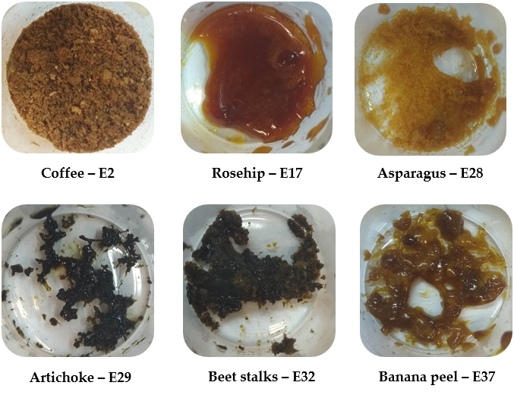
Figure S1. Aspect of the extracts selected as enhancers of Baculovirus Infections.

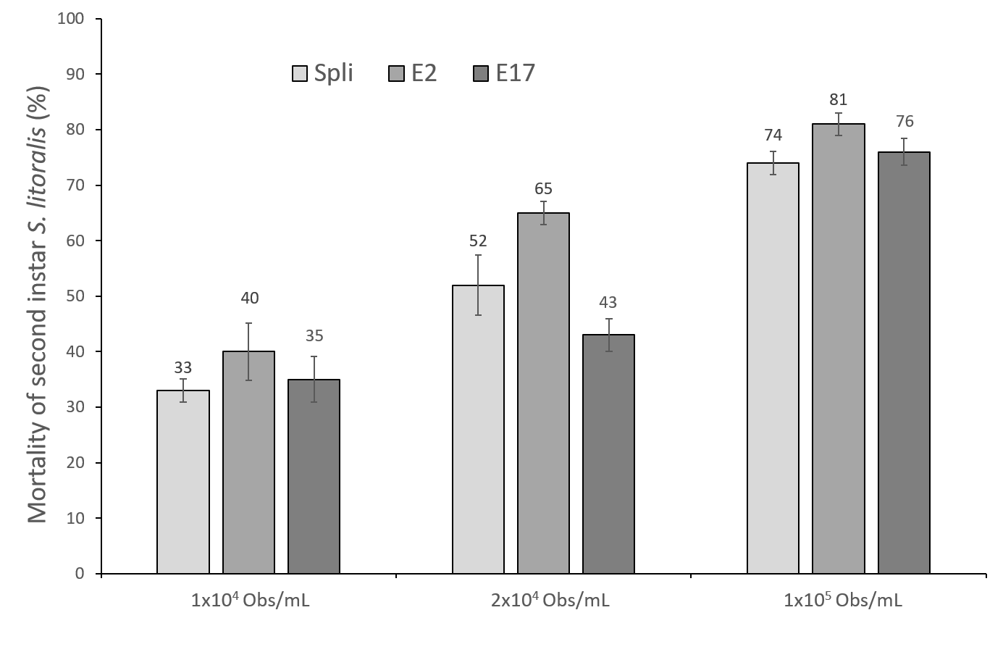

Figure S2. Percentage of mortality in second instar Spodoptera littoralis by SpliMNPV in presence and absence of 1% of extracts E2 and E17 using the droplet feeding method. Three viral concentrations were applied. The mortality obtained is indicated above the bars. The error bars indicated standard deviation.

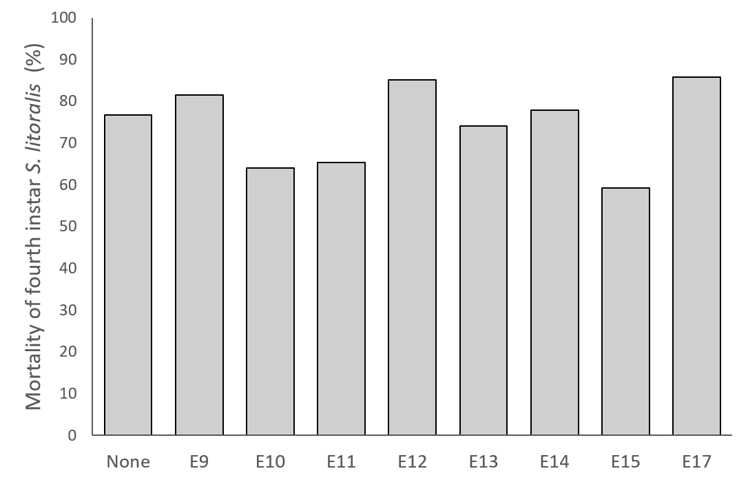

Figure S3. Percentage of larval mortality in fourth instar Spodoptera littoralis infected with SpliMNPV in presence of 1% of extracts E9, E10, E11, E12, E13, E14, E15 and E17, which was compared with that of control virus.

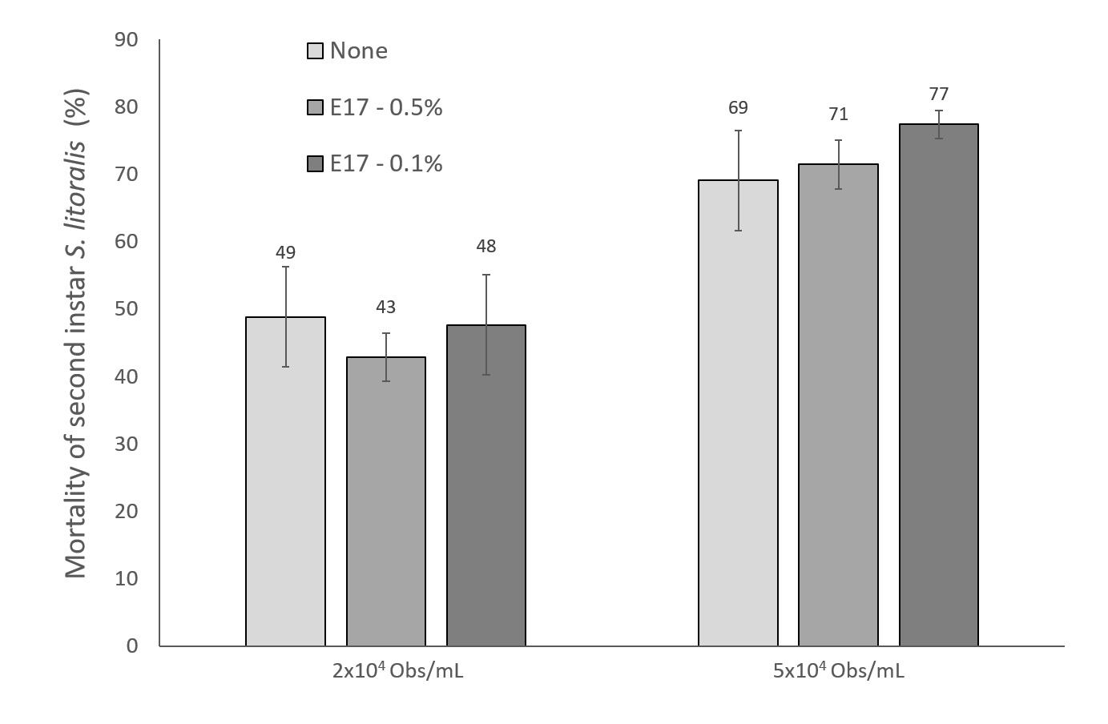

Figure S4. Percentage of mortality in second instar Spodoptera littoralis by SpliMNPV alone or in presence of extract E17 at two concentrations (0.5% and 0.1%). Two viral concentrations were applied. The mortality obtained is indicated above the bars. The error bars indicated standard deviation.

