Supplementary Information: Towards Cooling Concrete.
Materials and Methods
S1. Samples used for the experimental characterization.
All samples used in this study for experimental characterization were in powder form. Portlandite (Ca(OH)₂), with a purity exceeding 95%, was obtained from Sigma-Aldrich, while the aluminum-free tobermorite was synthesized following the method outlined in reference [1]. Regarding the cement clinkers, the study examined white cement (BL I 52.5 R cement) supplied by Cementos Cruz (Spain) and Ordinary Portland Cement (OPC CEM I 52.5 R) provided by Rezola. The oxide compositions of these materials are presented in Table S1.

Table S1. Oxide Composition of Materials (wt %)
Material | SiO₂ | Al₂O₃ | Fe₂O₃ | MnO | MgO | CaO | Na₂O | K₂O | Ti₂O | P₂O₅ | SO₃
WC | 20.74 | 3.76 | 0.16 | LD | 0.52 | 62.94 | LD | 0.64 | 0.23 | 0.05 | 3.26
OPC Clinker | 19.0 | 4.73 | 2.79 | 0.02 | 1.05 | 62.7 | 0.01 | 0.94 | 0.24 | 0.17 | 2.70

S2. Reflectivity measurement
The reflectivity of the four samples was measured at room temperature across a broad spectral range. For the UV-Near infrared range (0.4-2.1 µm), a portable spectrophotometer (410-SOLAR) with a tungsten filament as its light source was employed. Prior to measurements, the instrument underwent calibration using both specular and diffuse coupons to ensure accuracy. For the 2.1-15 µm range, a Fourier Transform Infrared (FTIR) spectrometer (Jasco 6300) equipped with an integrating sphere (PIKE) was utilized. The FTIR system employed a high-intensity ceramic source as the light source. The system was configured with a Ge/KBr beam splitter and a wideband MCT detector. To establish a reference baseline, a gold plate was employed.

S3 Complex permittivity extraction using Kramers-Kronig relations
Kramers-Konig relations have been extensively used to predict the optical parameters of materials with diverse characteristics, such as organic and inorganic semiconductors, polymers, multiferroics, superconductors, metallics, ceramics, and glass materials [2–6]. The complex permittivity of the CH, CSH, OPC and WC samples across the UV-Visible and IR spectra was extracted using the KK relations. This method applies the Hilbert transformation to the reflectance data to obtain the phase shift, which in turn is used to retrieve the complex refractive index [6]. Afterwards, the complex permittivity was obtained from it.
The KK relation is implemented differently based on the limit of the integral in the phase shift. One method requires the low-frequency extrapolation of the experimental reflectance data to zero and the high-frequency extrapolation of the experimental reflectance data to infinity [2,5,7]. The application of low-frequency extrapolation towards the experimental data and high-frequency extrapolation to infinity methods seldom produce optical data that deviates from the experimental values based on errors due to extrapolation outside the experimental reflectance data [4]. The primary contributing factor is the high-frequency extrapolation, which could compromise the optical characteristic over the entire frequency range [5]. Similarly, the oscillator fit procedure, which fits the required optical data to the experimental data and expresses the optical absorption data as a sum of damped classical oscillators [4], has been reported to be computationally demanding, material specific, and also deviate from the experimental optical data.
The KK relation based on the exact experimental reflectance data is preferred for several materials because it does not require the least square refinement or any information about the sample [6]. Similarly, it takes only the experimental reflectance data as input, and it does not require approximation or extrapolation outside the experimental data range, therefore generating more reliable optical data [4,6,8,9].
In the first step, we calculated the phase shift from the measured reflectance $R\left(ω\right)$ at a range of frequencies $ω$ by integrating the measured reflectance according to Equation (4).

$ϕ\left(ω\right)=-\frac{ω}{π}P\int_{0}^{∞}{\frac{\ln\left(R\left(ω'\right)\right)}{\left({\left(ω^{'}\right)}^{2}\right)-\left(ω^{2}\right)}}dω'$ (4)

The refractive index,$n\left(ω\right)$, and extinction coefficient, $k\left(ω\right)$, were then calculated using the relations (5) and (6):

$n\left(ω\right)=\frac{1-R\left(ω\right)}{1+R\left(ω\right)-2\sqrt{R\left(ω\right)}cos\left(ϕ\left(ω\right)\right)}$ (5)
$k\left(ω\right)=\frac{-2\sqrt{R\left(ω\right)}sin\left(ϕ\left(ω\right)\right)}{\left(1+R\left(ω\right)\right)-2\sqrt{R\left(ω\right)}cosϕ\left(ω\right)}$ (6)

where $R\left(ω\right)$ is the reflectance and $ϕ\left(ω\right)$is the phase shift.

The real ($ϵ_{1}$) and imaginary ($ϵ_{2}$) parts of the complex dielectric constant ($ϵ$) were finally obtained from the refractive index and extinction coefficient using (7) and (8).

$ϵ_{1}\left(ω\right)=n^{2}\left(ω\right)-k^{2}\left(ω\right)$ (7)
$ϵ_{2}(ω)=2n\left(ω\right)k\left(ω\right)$ (8)

S4. Techniques for modelling the emissivity response in homogeneous and heterogeneous structures
The spectral emissivity can be derived analytically from the complex permittivity (or refractive index and extinction coefficient) as it is done with homogeneous materials or structures composed of stratified homogeneous materials. In such cases, the measured complex permittivity values for materials in their homogeneous state can be used , as these are readily available in the literature [18]. These permittivity functions are subsequently employed in analytical or numerical simulations to optimize the desired emissivity spectrum. One common approach for this purpose is the use of the transfer-matrix method (TMM), particularly in planar single or multilayer structures [19].
In the case of heterogeneous materials, such as a host material with embedded microspheres, the Maxwell-Garnett homogenization rules [20] may be employed to estimate an effective complex permittivity based on the permittivities of the individual constituents [21,22]. The homogenized permittivity is then used to determine the optical behavior of the mixture in terms of reflectivity and emissivity. Nonetheless, this approach may not be optimal for highly complex and heterogeneous materials. This is exemplified by some innovative materials engineered for radiative cooling, including modified wood [23,24], geopolymers [25], and cementitious-based materials [26]. In such cases, optimization is typically achieved through an iterative process, whereby the emissivity is measured, and the mixture proportions are adjusted until an improved result is obtained without the explicit extraction of the constitutive relations of the materials, particularly their effective permittivity.
As explained in the main text, our approach differs by deriving an effective permittivity from experimental measurements using KK relations. This methodology enables a fundamental analysis of the materials' performance, offering a thorough understanding of their spectral characteristics and suitability for RC applications. Thanks to this method we get a first-hand knowledge insight into the electromagnetic response of the analyzed composites, which can be exploited in more complex future designs, whether by combining them with other materials or by structuring them to get some arbitrary response.

S5 Power Analysis of Passive Radiative Cooling Systems
Considering a material at temperature $T_{s}$ with its surface facing the sky and surrounded by ambient air at temperature $T_{amb}$ the power balance can be calculated as follows:

$P_{cool}(T_{s})=P_{rad}(T_{s})-P_{atm}(T_{amb})-P_{sun}-P_{cond+conv}(T_{s},T_{amb})$ (9)

The net cooling power ($P_{cool}$) is calculated by taking the thermal power radiated from the material surface ($P_{rad}$), and subtracting the absorbed solar irradiation power ($P_{sun}$), the absorbed power from the surrounding atmosphere ($P_{atm}$), and the device's heat convection and conduction environment ($P_{cond+conv}$) [13]. Each of these terms can be obtained as:

$P_{sun}=A\int_{0}^{∞}{{e(λ)I}_{sun}\left(λ\right)dλ}$ (10)

$P_{rad}(T_{s})=A\int{cosθdΩ}\int_{0}^{∞}{I_{bb}\left(T_{s},λ\right)e\left(λ,θ\right)dλ}$ (11)

$P_{atm}(T_{amb})=A\int{cosθdΩ}\int_{0}^{∞}{ I_{bb}\left(T,λ\right)e\left(λ,θ\right) \left(1-t(λ,θ)\right) dλ}$ (12)

$P_{cond+conv}\left(T_{s},T_{amb}\right)={A∙h}_{c}(T_{amb}-T_{s})$ (13)

Where $A$ is the area of the emitter, $\int{dΩ }$is the solid angle integral over a hemisphere, $I_{bb}$ is the spectral blackbody irradiance at temperature $T$ and wavelength $λ$ , and $h_{c}$ is a comprehensive non-radiative heat transfer coefficient that considers thermal conduction and convection. Based on the box model, the angular dependence of the atmospheric transmittance is approximated as ${t(λ,0)}^{1/{\cos{θ}}}$ [14]. A detailed explanation of these calculations can be found elsewhere [15,16].

S6 Atmospheric and external heat convection coefficient modelling
In the studies of RC the atmospheric conditions as well as the heat convection are of paramount importance, as they can change largely the performance of the structures. In our study, the spectral atmospheric response was characterizedover the course of a year, with a one-hour step resolution, using an average of the weather data from the last 10 years at each site. Atmospheric models were obtained from MODTRAN [10] throughout the year using an automated code, as atmospheric conditions, determined by relative humidity, dew point temperature, ambient temperature, precipitable water, etc., change throughout the day. In total, 8762 resulting values were analyzed for each location. The MODTRAN models were calibrated for each specific location and day. The calculated atmospheric transmittance models for each location are shown in Fig. S2 of the section “S3. Atmospheric transmittance for the chosen locations obtained from Modtran” where the decrease in atmospheric transmittance with increasing water column due to the absorption of infrared radiation by water vapor can be appreciated.
To calculate the external heat convection coefficient, we selected McAdams' model, as it is widely used in building energy simulations, particularly its implementation in the ESP-r software [11,12]. It should be noted that this model may slightly underestimate exterior convection values due to its lower coefficients compared to the linearized model. Despite this potential limitation, we chose this approach because our simulations focus on a flat, horizontal surface, such as a roof. The validation of the algorithm incorporating both the atmospheric and external heat convection coefficient models is presented in section “S4. Validation of the atmospheric models and net cooling power calculations.”

S7 Global settlement distribution based on climate.
As depicted in Fig. S8, a significant proportion of human settlements worldwide tend to concentrate in regions characterized by warm temperate climates. For the purpose of this study, one city was selected from each of these distinct climate groups following the Köppen-Geiger climate classification[27] each with a varying degree of refrigeration requirements: Singapore, representing an equatorial climate (Af); Phoenix, exemplifying an arid climate (BSh); and Pamplona, situated within a temperate climate zone (Cfb). Moreover, Singapore and Phoenix have been widely studied in heat mitigation research.[28,29]

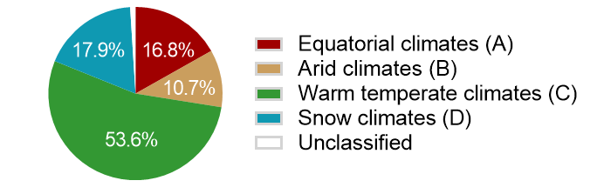
Fig.S7. Global settlement distribution based on climate.

S8 Atmospheric transmittance for the chosen locations obtained from Modtran
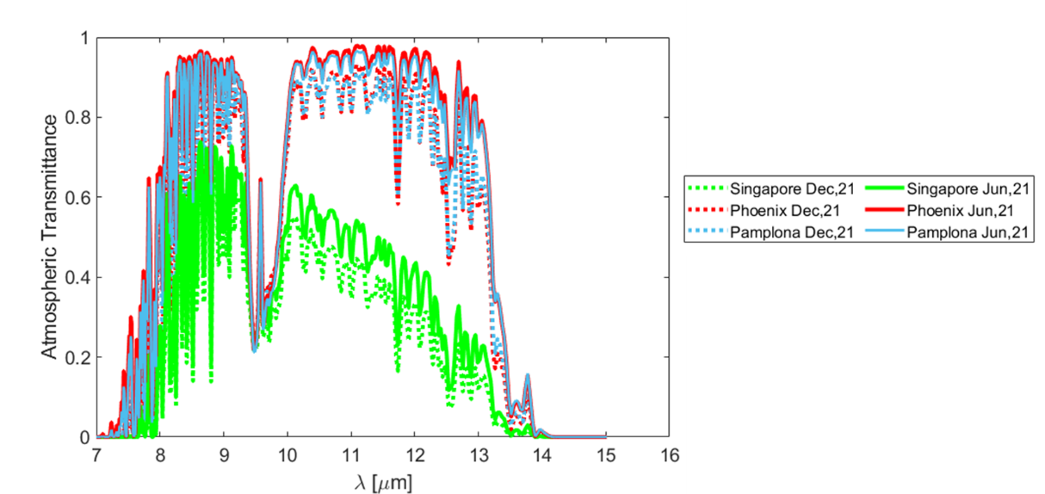
Fig. S8. Atmospheric transmittance for Singapore, Phoenix and Pamplona at summer and winter solstices.

S9 Validation of the atmospheric models and net cooling power calculations.
To validate our model, we reproduced the results of a well-established photonic radiative cooler reported in [13]. The experimental results of the article were obtained with the radiative cooling material exposed to the sky, utilizing a convection barrier constructed from low-density polyethylene to minimize convective heat transfer. These measurements were taken over a five-hour period. In addition to the excellent radiative cooling performance reported in that article, we chose that work as a benchmark for our model because it provided essential data, including material emissivity, ambient temperature (°C) at the location (Stanford, California), the experiment date (a clear winter day in mid-December), solar irradiation in W m−2, and values for conductive and convective losses in W m⁻² K ⁻¹.
Fig. S10 presents the comparison between the measured reported data in [13] and the temperature calculated using our method. The standard deviation, mean squared error and coefficient of determination are 1.6, 0.13 and 0.95, respectively demonstrating a reasonably good agreement between our calculated temperatures and the experimental measurements. These results validated the proposed procedure to calculate the net cooling power and steady-state temperature difference considering real climate conditions.
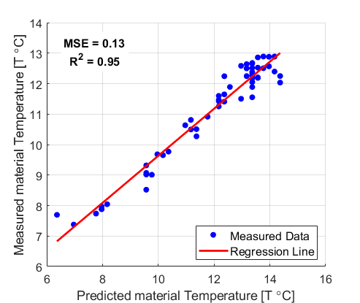
Fig. S9. Linear regression of the measured data predicted by the employed procedure for calculation of the net cooling power and steady state temperature difference.

S10. Indoor measurements setup
In the indoor measurements setup, a 500 W halogen lamp was used to simulate solar radiation [17], while the irradiance was measured by a pyranometer (APOGEE SP610), capable of measuring between 0.378 and 2.1 µm. By varying the distance of the lamp from the samples, the three solar irradiances were selected. The powder samples were placed above four pt-100 planar temperature sensors in Kapton with a rectangular shape (0.3×13×32 mm). The thickness of the sample powder was approximately 2 mm.

References

[1] M. Diez-Garcia, J.J. Gaitero, F.B. Aguirre, E. Erkizia, J.T. San-Jose, C. Aymonier, J.S. Dolado, Synthesis and Addition of Al-Substituted Tobermorite Particles to Cement Pastes, Journal of Materials in Civil Engineering 34 (2022). https://doi.org/10.1061/(ASCE)MT.1943-5533.0004486.
[2] P. Grosse, V. Offermann, Analysis of reflectance data using the Kramers-Kronig Relations, Applied Physics A 52 (1991) 138–144.
[3] T.S. Robinson, Optical constants by reflection, Proceedings of the Physical Society. Section B 65 (1952) 910.
[4] H. Durmuş, H. Şafak, H. Karabiyik, Determination of Optical Constant of Materials by two Different Methods: An Application to Single Crystals Si, Turkish Journal of Physics 24 (2000) 725–735.
[5] D.B. Tanner, Use of x-ray scattering functions in Kramers-Kronig analysis of reflectance, Physical Review B 91 (2014) 35123.
[6] K. Yamamoto, A. Masui, Complex Refractive Index Determination of Bulk Materials from Infrared Reflection Spectra, Applied Spectroscopy 49 (1995) 639–644.
[7] H. Phillip, E.A. Taft, Kramers-Kronig Analysis of Reflectance Data for Diamond, Physical Review 136 (1964).
[8] T.G. Mayerhöfer, V. Ivanovski, J. Popp, Infrared refraction spectroscopy - Kramers-Kronig analysis revisited., Spectrochimica Acta. Part A, Molecular and Biomolecular Spectroscopy 270 (2021) 120799.
[9] D.M. Roessler, Kramers-Kronig analysis of reflection data, British Journal of Applied Physics 16 (1965) 1119–1123.
[10] A. Berk, P. Conforti, R. Kennett, T. Perkins, F. Hawes, J. Van Den Bosch, MODTRAN®6: A major upgrade of the MODTRAN®radiative transfer code, in: 2014 6th Workshop on Hyperspectral Image and Signal Processing: Evolution in Remote Sensing (WHISPERS), IEEE, 2014: pp. 1–4.
[11] M. Mirsadeghi, D. Cóstola, B. Blocken, J.L.M. Hensen, Review of external convective heat transfer coefficient models in building energy simulation programs: Implementation and uncertainty, Applied Thermal Engineering 56 (2013) 134–151. https://doi.org/10.1016/j.applthermaleng.2013.03.003.
[12] ESP-r | University of Strathclyde, (n.d.). https://www.strath.ac.uk/research/energysystemsresearchunit/applications/esp-r/ (accessed August 28, 2024).
[13] A.P. Raman, M.A. Anoma, L. Zhu, E. Rephaeli, S. Fan, Passive radiative cooling below ambient air temperature under direct sunlight, Nature 515 (2014) 540–544.
[14] C.G. Granqvist, A. Hjortsberg, Radiative cooling to low temperatures: General considerations and application to selectively emitting SiO films, Journal of Applied Physics 52 (1981) 4205–4220.
[15] B. Zhao, M. Hu, X. Ao, N. Chen, G. Pei, Radiative cooling: A review of fundamentals, materials, applications, and prospects, Applied Energy 236 (2019) 489–513. https://doi.org/10.1016/j.apenergy.2018.12.018.
[16] M. Chen, D. Pang, X. Chen, H. Yan, Y. Yang, Passive daytime radiative cooling: Fundamentals, material designs, and applications, EcoMat 4 (2022) e12153. https://doi.org/10.1002/eom2.12153.
[17] J. Wei, Z. Nie, G. He, L. Hao, L. Zhao, Q. Zhang, Energy harvesting from solar irradiation in cities using the thermoelectric behavior of carbon fiber reinforced cement composites, RSC Adv. 4 (2014) 48128–48134. https://doi.org/10.1039/C4RA07864K.
[18] RefractiveIndex.INFO - Refractive index database, (n.d.). https://refractiveindex.info/ (accessed September 24, 2023).
[19] C.C. Katsidis, D. Siapkas, General transfer-matrix method for optical multilayer systems with coherent, partially coherent, and incoherent interference., Applied Optics 41 19 (2002) 3978–3987.
[20] V.A. Markel, Maxwell Garnett approximation in random media: tutorial., Journal of the Optical Society of America. A, Optics, Image Science, and Vision 39 4 (2022) 535–544.
[21] T.M.J. Nilsson, G.A. Niklasson, C.G. Granqvist, A solar reflecting material for radiative cooling applications : ZnS pigmented polyethylene, Solar Energy Materials and Solar Cells 28 (1992) 175–193.
[22] J.M. Pérez-Escudero, A.E. Torres-García, C. Lezaun, A. Caggiano, I. Peralta, J.S. Dolado, M. Beruete, I. Liberal, Suppressed-scattering spectral windows for radiative cooling applications., Optics Express 31 4 (2022) 6314–6326.
[23] T. Li, Y. Zhai, S. He, W. Gan, Z. Wei, M. Heidarinejad, D.A. Dalgo, R. Mi, X. Zhao, J. Song, J. Dai, C. Chen, A. Aili, A. Vellore, A. Martini, R. Yang, J. Srebric, X. Yin, L. Hu, A radiative cooling structural material, Science 364 (2019) 760–763.
[24] Y. She, J. Wang, C. Zhu, F. Tian, Y. Jin, W. Mao, Y. Wu, K. Chen, X. Xu, From nature back to nature: Spectrally modified poplar and its all-day passive radiative cooling, Industrial Crops and Products 193 (2023) 116242. https://doi.org/10.1016/j.indcrop.2023.116242.
[25] N. Yang, Y. Fu, X. Xue, D. Lei, J.-G. Dai, Geopolymer-based sub-ambient daytime radiative cooling coating, EcoMat 5 (2023) e12284. https://doi.org/10.1002/eom2.12284.
[26] G.Q.M. Lu, W. She, X. Tong, W. Zuo, Y. Zhang, Radiative cooling potential of cementitious composites: Physical and chemical origins, Cement \& Concrete Composites 119 (2021) 104004.
[27] M. Kottek, J. Grieser, C. Beck, B. Rudolf, F. Rubel, World Map of the Köppen-Geiger climate classification updated, Meteorologische Zeitschrift 15 (2006) 259–263.
[28] J. Feng, K. Gao, M. Santamouris, K.W. Shah, G. Ranzi, Dynamic impact of climate on the performance of daytime radiative cooling materials, Solar Energy Materials and Solar Cells 208 (2020) 110426.
[29] D. Han, B.F. Ng, M.P. Wan, Preliminary study of passive radiative cooling under Singapore’s tropical climate, Solar Energy Materials and Solar Cells 206 (2020) 110270.

