Supplementary material.
Table S1. Main characteristics of the vineyards studied in each region, number of trials, location, years of study, varieties, grape color, rootstock, soil texture, annual reference evapotranspiration (ETo) and annual rainfall.
Region | Field trials | Location | Years of study | Variety | Grape color | Rootstock | Soil texture | *Annual ETo (mm) | Annual rainfall (mm)
Galicia  (ES-GA) | 1 | 42°21'N 8°07'W | 2012-2014 | Albariño | White | 196-17C | sandy-loam | 1080 (79%) | 1765 (43%)
Galicia  (ES-GA) | 2 | 42°21'N 8°07'W | 2012-2014 | Brancellao | White | 196-17C | sandy-loam | 1080 (79%) | 1765 (43%)
Galicia  (ES-GA) | 3 | 42°21'N 8°07'W | 2012-2014 | Godello | White | 196-17C | sandy-loam | 1080 (79%) | 1765 (43%)
Galicia  (ES-GA) | 4 | 42°21'N 8°07'W | 2012-2014 | Sousón | White | 196-17C | sandy-loam | 1080 (79%) | 1765 (43%)
Galicia  (ES-GA) | 5 | 42°21'N 8°07'W | 2012-2014 | Treixadura | White | 196-17C | sandy-loam | 1080 (79%) | 1765 (43%)
Galicia  (ES-GA) | 6 | 41°56'N 8°49'W | 2012-2018 | Albariño | White | 110-Richter | sandy-loam | 1092 (82%) | 1584 (40%)
Galicia  (ES-GA) | 7 | 42°15'N 8°28'W | 2012-2014 | Godello | White | 110-Richter | loam | 1081 (81%) | 764 (32%)
Castilla y León (ES-CL) | 1 | 39°03'N 2°04'W | 2009-2011 | Tempranillo | Red | 110-Richter | loam-clay-sandy | 1115 (86%) | 394 (39%)
Castilla y León (ES-CL) | 2 | 41°21'N 4°56'W | 2012-2014 | Verdejo | White | 110-Richter | loam-clay-sandy | 1210 (84%) | 235 (54%)
Castilla y León (ES-CL) | 3 | 41°21'N 4°56'W | 2016-2018 | Verdejo | White | 110-Richter | loam-clay-sandy | 1234 (84%) | 252 (47%)
Extremadura (ES-EX) | 1 | 38°51'N 6°40'W | 2009-2011 | Tempranillo | Red | 110-Richter | loam-clay-sandy | 1341 (81%) | 552 (32%)
Extremadura (ES-EX) | 2 | 38°49'N 6°34'W | 2012-2014 | Cigüente | White | 110-Richter | loam-clay | 1265 (81%) | 520 (46%)
Extremadura (ES-EX) | 3 | 38°42'N 6°50'W | 2016-2018 | Macabeo | White | 110-Richter | loam-clay | 1222 (78%) | 330 (51%)
Castilla la Mancha  (ES-CM) | 1 | 39°07'N 3°05'W | 2005-2006 | Merlot | Red | Fercal | sandy-loam | 1393 (83%) | 263 (48%)
Castilla la Mancha  (ES-CM) | 2 | 38°41'N 1°26'W | 2016 | Monastrell | Red | SO-4 | sandy-loam | 1248 (78%) | 361 (51%)
Castilla la Mancha  (ES-CM) | 3 | 38°41'N 1°26'W | 2017-2018 | Monastrell | Red | SO-4 | sandy-loam | 1209 (78%) | 315 (47%)
Castilla la Mancha  (ES-CM) | 4 | 39°03'N 2°04'W | 2012-2014 | Airén | White | 110-Richter | loam-clay-sandy | 1292 (81%) | 343 (45%)
Castilla la Mancha  (ES-CM) | 5 | 39°03'N 2°04'W | 2012-2015 | Macabeo | White | 110-Richter | loam-clay-sandy | 1292 (81%) | 343 (45%)
Castilla la Mancha  (ES-CM) | 6 | 39°14'N 2°35'W | 2016-2018 | Airén | White | 110-Richter | loam-clay-sandy | 1313 (81%) | 352 (47%)
Navarra  (ES-NC) | 1 | 41°59'N 1°41'W | 2004-2005 | Tempranillo | Red | 1103-Paulsen | loamy-clay-loam | 1125 (78%) | 503 (44%)
Navarra  (ES-NC) | 2 | 42°22'N 1°38'W | 2003-2005 | Tempranillo | Red | 110-Richter | loam-clay | 1199 (83%) | 482 (63%)
La Rioja  (ES-RI) | 1 | 42°26'N 2°17'W | 2002-2004 | Tempranillo | Red | 110-Richter | loam | 1048 (81%) | 538 (58%)
La Rioja  (ES-RI) | 2 | 42°26'N 2°17'W | 2002-2004 | Cabernet Sauvignon | Red | 110-Richter | loam | 1048 (81%) | 538 (58%)
La Rioja  (ES-RI) | 3 | 42°26'N 2°17'W | 2002-2004 | Garnacha | Red | 110-Richter | loam | 1048 (81%) | 538 (58%)
La Rioja  (ES-RI) | 4 | 42°26'N 2°17'W | 2002-2004 | Graciano | Red | 110-Richter | loam | 1048 (81%) | 538 (58%)
La Rioja  (ES-RI) | 5 | 42°26'N 2°17'W | 2002-2005 | Mazuelo | Red | 110-Richter | loam | 1048 (81%) | 538 (58%)
La Rioja  (ES-RI) | 6 | 42°13'N 1°51'W | 2016-2018 | Tempranillo Blanco | White | 110-Richter | loam | 1080 (82%) | 449 (52%)
Comunidad Valenciana (ES-VC) | 1 | 39°29'N 1°12'W | 2000-2005 | Tempranillo | Red | 161-49C | clay loam-light clay | 1123 (80%) | 368 (47%)
Comunidad Valenciana (ES-VC) | 2 | 39°29'N 1°12'W | 2003-2004 | Tempranillo | Red | 161-49C | clay loam-light clay | 1055 (77%) | 421 (51%)
Comunidad Valenciana (ES-VC) | 3 | 39°29'N 1°12'W | 2000-2004 | Tempranillo | Red | 161-49C | clay loam-light clay | 1103 (80%) | 386 (47%)
Comunidad Valenciana (ES-VC) | 4 | 39°29'N 1°12'W | 2000-2001 | Bobal | Red | 110-Richter | clay loam-light clay | 1155 (76%) | 554 (46%)
Comunidad Valenciana (ES-VC) | 5 | 39°29'N 1°12'W | 2012-2014 | Bobal | Red | 110-Richter | clay loam-light clay | 1091 (77%) | 351 (61%)
Comunidad Valenciana (ES-VC) | 6 | 39°29'N 1°12'W | 2007-2009 | Tempranillo | Red | 161-49C | clay loam-light clay | 1079 (79%) | 440 (65%)
Comunidad Valenciana (ES-VC) | 7 | 39°29'N 1°12'W | 2009-2011 | Cabernet Sauvignon | Red | 161–49C | sandy-loam | 1069 (81%) | 441 (50%)
Comunidad Valenciana (ES-VC) | 8 | 39°29'N 1°06'W | 2009-2011 | Tempranillo | Red | 161–49C | clay | 1069 (81%) | 441 (50%)
Comunidad Valenciana (ES-VC) | 9 | 39°29'N 0°43'W | 2012-2014 | Moscatel | White | 161–49C | loam-clay | 1091 (77%) | 351 (61%)
Cataluña  (ES-CA) | 1 | 41°09'N 1°12'E | 1997-2000 | Tempranillo | Red | 110-Richter | loam-clay-sandy | 1030 (78%) | 395 (59%)
Cataluña  (ES-CA) | 2 | 41°07'N 0°47'E | 2003-2004 | Tempranillo | Red | 110-Richter | sandy-loam | 827 (83%) | 610 (39%)
Cataluña  (ES-CA) | 3 | 41°09'N 1°12'E | 1996-2000 | Cabernet Sauvignon | Red | 110-Richter | clay loam-light clay | 1046 (78%) | 417 (62%)
Islas Baleares (ES-IB) | 1 | 39°38'N 2°38'E | 2016-1028 | Tempranillo | Red | 110-Richter | loam-clay | 1001 (80%) | 377 (43%)
Islas Baleares (ES-IB) | 2 | 39°38'N 2°38'E | 2016-2018 | Garnacha | Red | 110-Richter | loam-clay | 1079 (81%) | 398 (41%)
* Annual evapotranspiration and annual rainfall data indicate the average over the years of the trial. The values in brackets represent the percentage corresponding to the growing season (April to October).

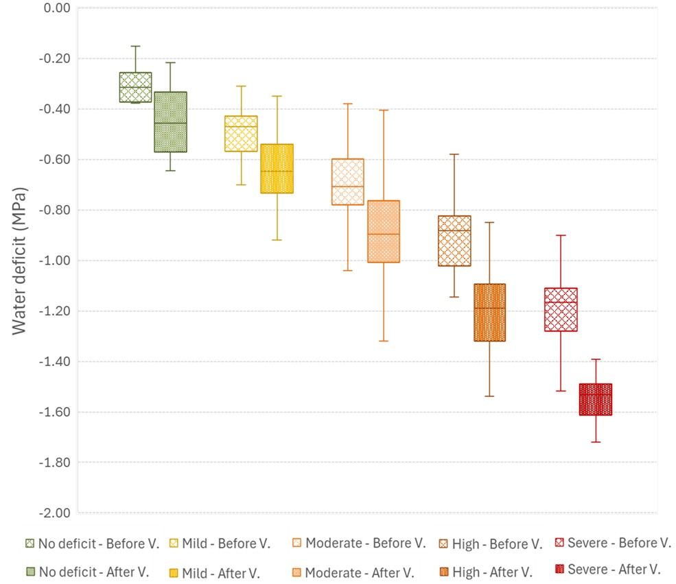
Figure S1. Range of water deficit values found before and after veraison (V.) in the observations used in this study, according to the overall water deficit level experienced by them throughout the growing season.

