Supplementary data

Innovative catalyst integration on transparent silicone microreactors for photocatalytic applications

Ismael Pellejero1,*, Alberto Clemente1, Santiago Reinoso1, Alfonso Cornejo1, Alberto Navajas1, José J. Vesperinas2, Miguel A. Urbiztondo3,*, Luis M. Gandía1

1Institute for Advanced Materials (InaMat); Public University of Navarre (UPNA); Edificio Jerónimo de Ayanz, Campus de Arrosadia, 31006 Pamplona-Iruña, Spain.

2Servicio de Apoyo a la Investigación; Public University of Navarre (UPNA); Edificio El Sario, Campus de Arrosadia, 31006 Pamplona-Iruña, Spain.

3Centro Universitario de la Defensa; Academia General Militar, Ctra. Huesca s/n, 50090 Zaragoza, Spain.

*Corresponding Authors: urbiz@unizar.es (M.A.U.), lgandia@unavarra.es (L.M.G.)

# Microreactor Designs and Fabrication

Table S1. Theoretical dimensions of the two microreactor designs fabricated in this work.

|  |  |  |
| --- | --- | --- |
| **ABS Mold Design** | C:\Users\ismael\Desktop\EMPEZADO  Paper reactor PDMS con NP embebidas en el Polimero\imagenes para articulo PDMS y NP\reactor 05mm.jpg  32 mm  0.5 × 0.5 | C:\Users\ismael\Desktop\EMPEZADO  Paper reactor PDMS con NP embebidas en el Polimero\imagenes para articulo PDMS y NP\reactor 1mm.jpg  32 mm  1 × 1 |
| **Squared Side (mm)** | 0.5 | 1 |
| **Total Length (mm)** | 1070 | 420 |
| **Total Volume (mm3)** | 210 | 420 |
| **Coated Surface (mm2)[a]** | 1605 | 1260 |
| **Estimated Catalyst Load (mg)[b]** | 12.2 | 9.6 |
| **Final Microreactors** |  |  |

**[a] 3 sides**

**[b] Estimation considering a catalyst layer thisckness of 2 µm and a bulk density of 3.8 g·cm3**

Scheme S1. Location of the 3D-printed ABS mold inside the molding container before the PDMS casting step

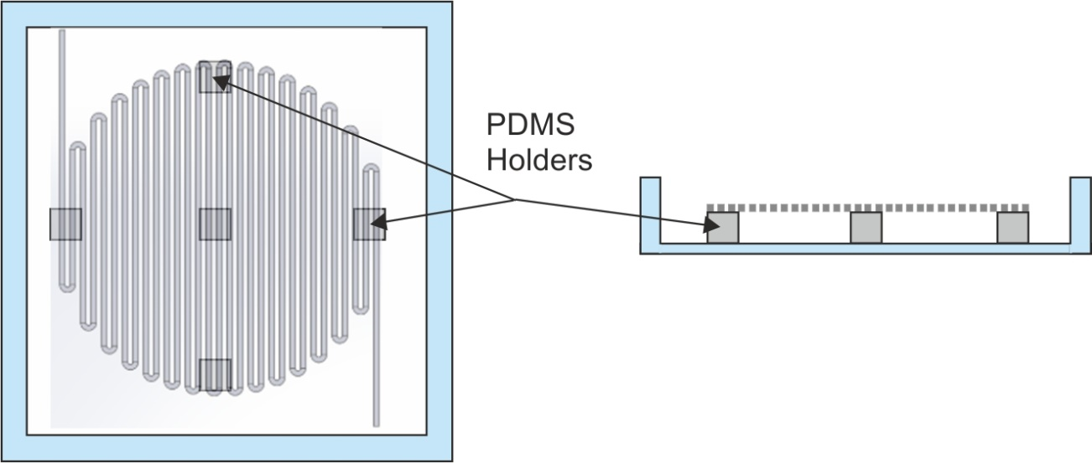

# Experimental Set-Up for the Photocatalytic Test Reactions.

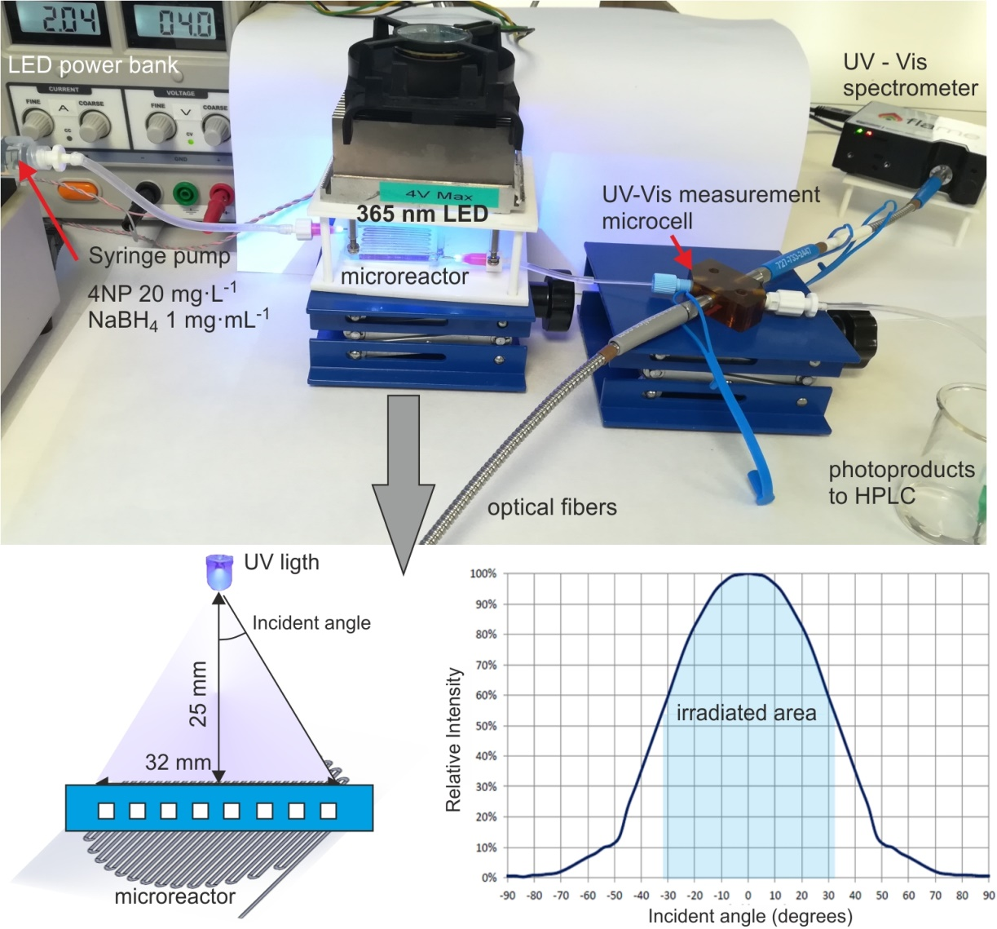

Fig. S1. Experimental set-up for the photocatalytic reduction of 4-nitrophenol to 4-aminophenol by using silicone microreactors with continuous UV-Vis analysis. Scheme of the light configuration and relative intensity versus incident angle for the 365 nm LED.

# HPLC Analyses

HPLC analyses were performed on an Agilent 1100 chromatograph coupled to an UV-Vis detector set at 245 nm. The stationary phase was a Phenomenex Kinetex 5 u EVO C18 (100 Å 150 x 4.6 mm, part number 00F-4633-E0) that was kept at 35 ºC. The mobile phase consisted on a mixture of solvent A (75 mM Na2HPO4 (Acros Organics) and 5 mM sodium heptanesulfonate (Acros Organics) in H2O) and solvent B (4 g L-1 tetrabutylammonium hydroxide (Acros Organics) in H2O) eluted at 0.7 mL min-1. A gradient of B concentration was used (25 % B for 2.6 min, 25 to 100 % during 7.4 min, and 100 to 25 % during 5 min). The retention time of 4-aminophenol (4AP) was 2.3 min (Figure S2).

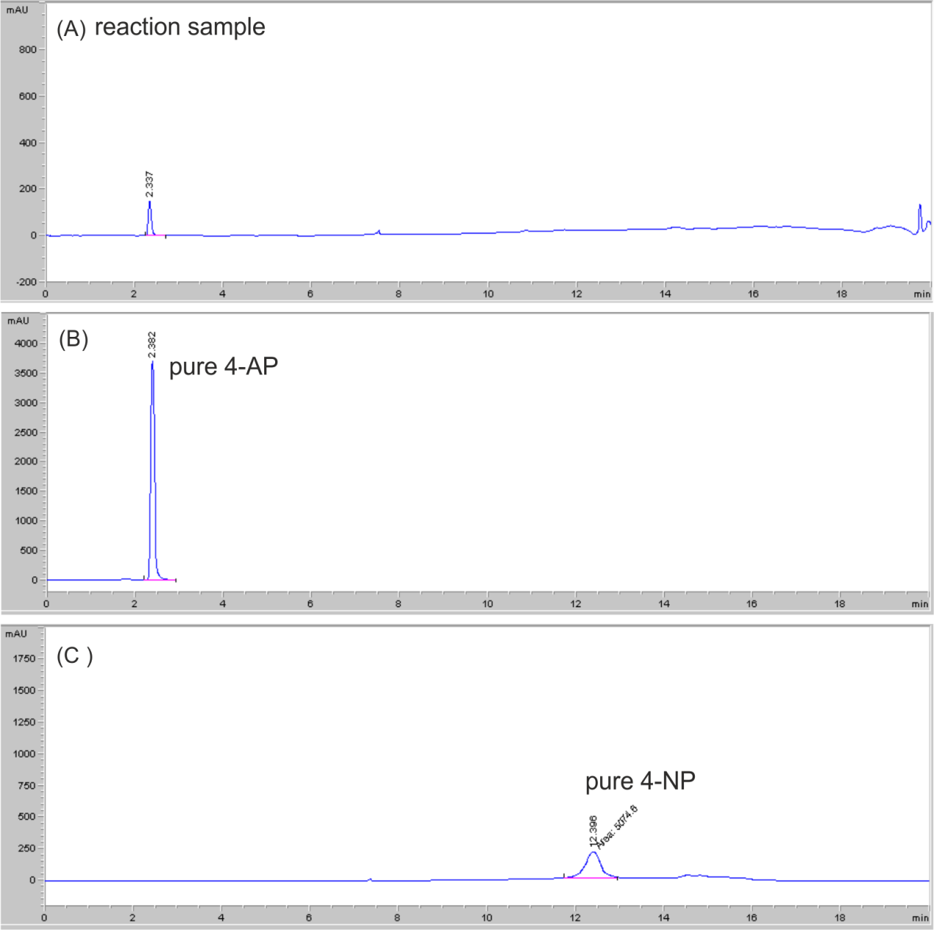

Fig. S2. (A) Detection of 4-aminophenol (4AP) in a sample of the reaction photoproducts at a retention time of 2.3 min; (B) determination of retention time for pure 4AP; (C) determination of retention time for pure 4-nitrophenol (4NP)

# Fabrication Results

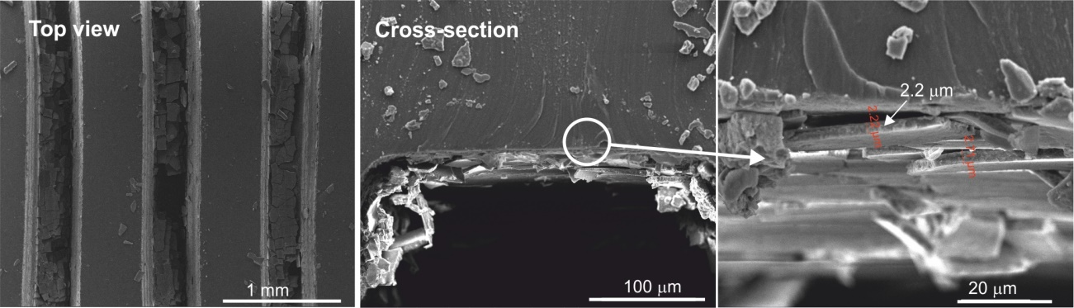

Fig. S3. SEM images of the silicone microreactors (0.5 × 0.5) obtained from the direct functionalization of the microchannels with the Au@POM/TiO2 nanoparticles by dip-coating.

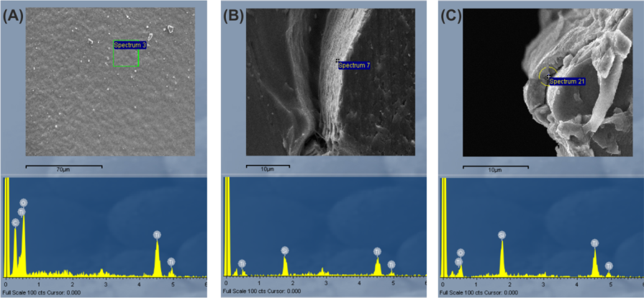

Fig. S4. EDX analyses of the coated silicone microreactors (0.5 × 0.5) at different fabrication stages. (A) ABS mold coated with Au@POM/TiO2 nanoparticles upon the dip-coating step; (B) Au@POM/TiO2-coated ABS mold embedded within the PDMS block upon the PDMS casting step; (C) PDMS microchannels coated with the Au@POM/TiO2 photocatalyst upon the ABS removal step by treatment with acetone.

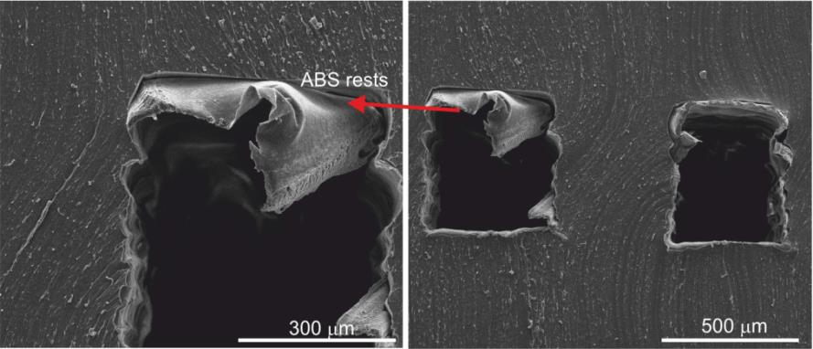

Fig. S5. SEM images of a silicone microreactor (0.5 × 0.5) for which the ABS removal step by acetone treatment was non-effective.

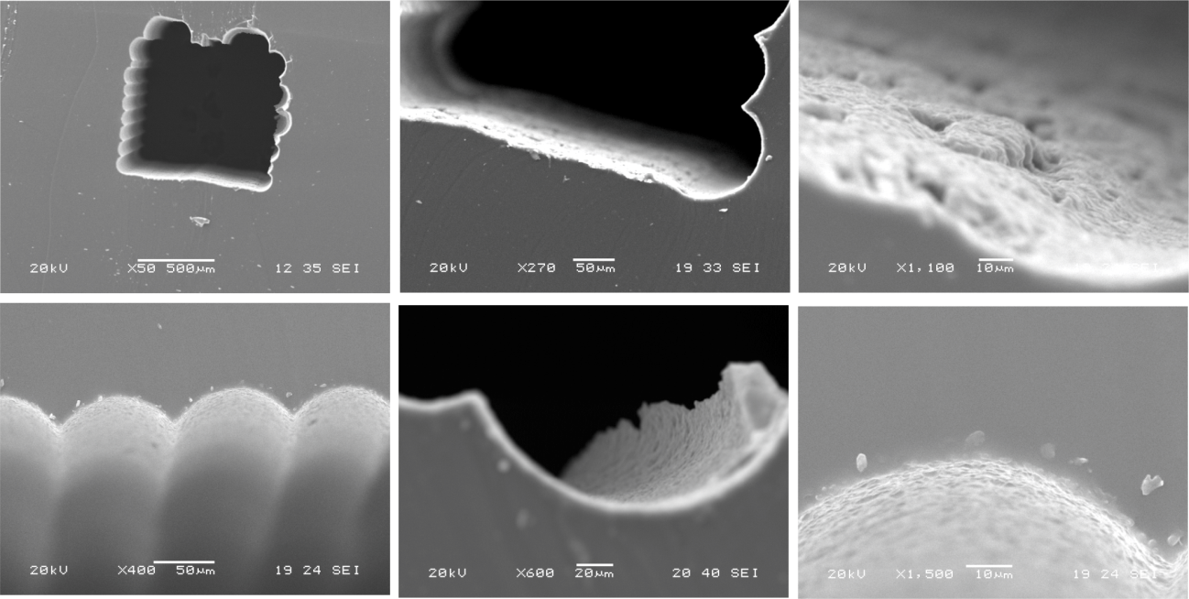

Fig. S6. SEM images of the coated silicone microreactors with 1 × 1 design.