SUPPLEMENTARY MATERIAL
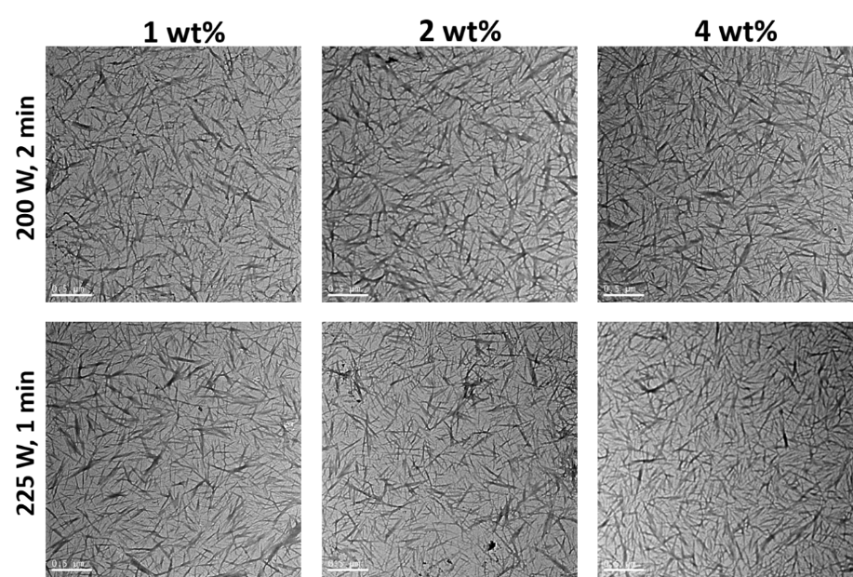
Figure 1S. TEM images of chitin nanowhiskers (CNWs) in Milli-Q water (final dilution 0.1 mg/mL) as a function of ultrasonication parameters (power (W) and time (min)) and CNW concentration (n=2).
An ultrasonicator (Sonic Ruptor 250, Omni International, Kennesaw, USA) was used to disperse the CNWs in MQW. Aliquots of CNWs (2.5, 5, and 10 mg/mL) were prepared in 10 mL of MWQ. The suspensions (n= 2) were then ultrasonicated with different times and power and analysed using a transmission electron microscope (TEM, FEI Tecnai 12) to select the best ultrasonication parameters for a good dispersibility of CNWs. Transmission electron micrographs were obtained at an accelerating voltage of 120 kV. A 1 µL droplet of CNWs dispersion dilution (0.1 mg/mL) was placed on a carbon-coated copper grid and left to dry before analysing the dispersibility of CNWs as a function of ultrasonication treatment.
Either 200 W for 2 min or 225 W for 1 min resulted in effective ultrasonication parameters to disperse CNWs in MWQ. Lower ultrasonic power and times did not completely disperse the CNWs in MWQ, as observed by the naked eye. In this study, the ultrasonication of CNWs was carried out at 225 W for 1 min.

Figure 2S. FTIR spectra of individual components used in film preparation (CNWs means chitin nanowhiskers).
Figure 3S. FTIR spectra of the amide I band and its second derivative (deriv.) for non-heated (NH) and heat-treated (HT) gelatin films, containing different concentrations of chitin nanowhiskers (0, 1, 2, & 4 wt% on a gelatin dry weight basis) (n=3) (the two Y axes have different scales).

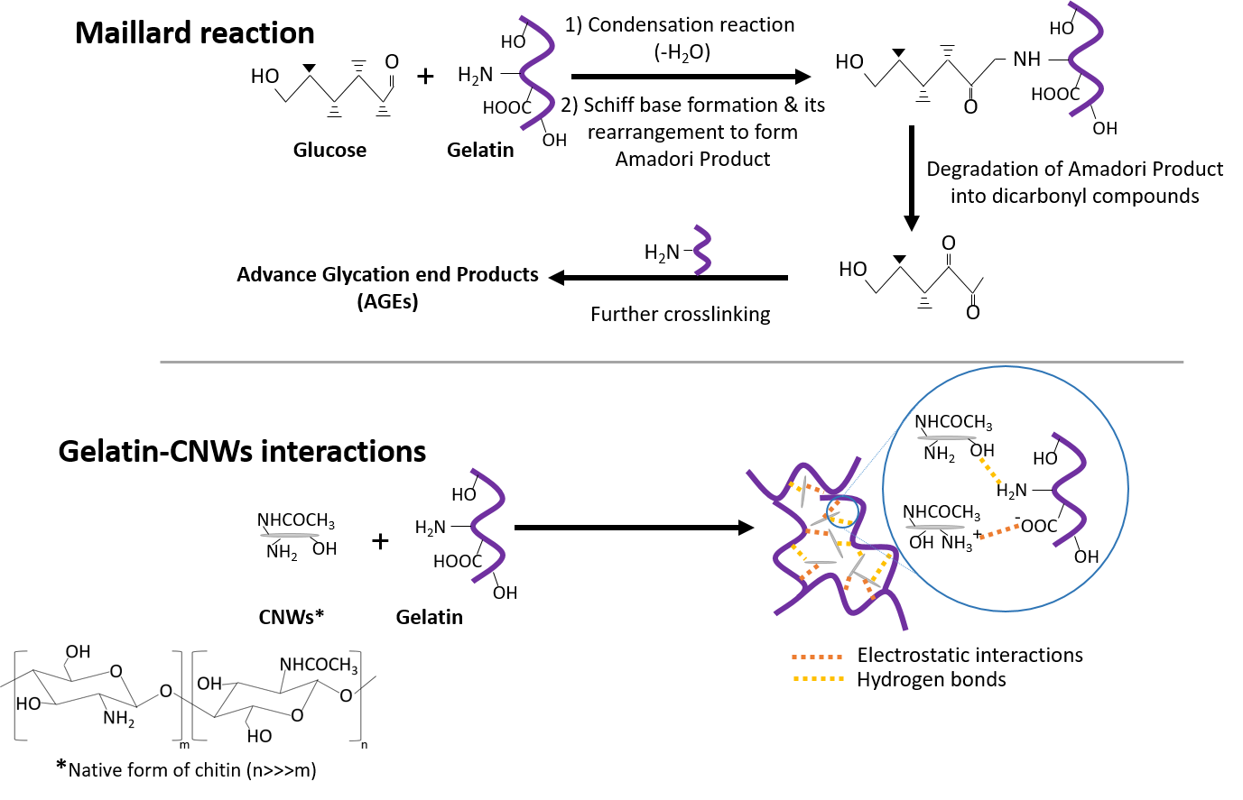
Figure 4S. Simplified Maillard reaction scheme between gelatin and glucose, and interactions between gelatin and chitin nanowhiskers (CNWs).

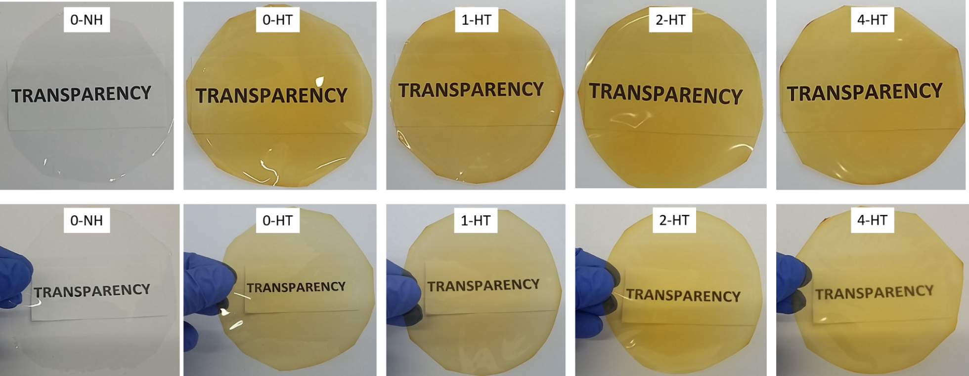
Figure 5S. Non-heated (NH) and heat-treated (HT) gelatin films with different concentrations (0, 1, 2 and 4 wt%, on a gelatin dry weight basis) of chitin nanowhiskers. The upper row: films in contact with the surface of the paper; the bottom row: films in non-contact with the surface.

Figure 6S. UV-Vis spectra of compounds released from non-heated (NH) and heat-treated (HT) gelatin films containing different concentrations of chitin nanowhiskers (0, 1, 2 & 4 wt%, on a gelatin dry weight basis) into Milli-Q water (n=3).
Table 1S. Ultrasonication parameters’ (power and time) effect on the dispersibility of chitin nanowhiskers in Milli-Q water as a function of their concentration (n=2).
Solution | Power (W) | Time (on/off) | Dispersibility*
1 wt% | 175 | (1 min/1 min)x4 | Not completely dispersed
4 wt% | 200 | 1 min | Not completely dispersed
 |  | (1 min/1 min)x2 | Completely dispersed
2 wt% | 200 | 1 min | Not completely dispersed
 |  | (1 min/1 min)x2 | Completely dispersed
1 wt% | 200 | 1 min | Not completely dispersed
 |  | (1 min/1 min)x2 | Completely dispersed
4 wt% | 225 | 30 sec | Not completely dispersed
 |  | (30 sec/30 sec)x2 | Completely dispersed
2 wt% | 225 | 30 sec | Not completely dispersed
 |  | (30 sec/30 sec)x2 | Completely dispersed
1 wt% | 225 | 30 sec | Not completely dispersed
 |  | (30 sec/30 sec)x2 | Completely dispersed
* Visible to the naked eye

Table 2S. Amide A, I, II, and III, as well as saccharide band wavenumber for non-heated (NH) and heat-treated (HT) gelatin films containing different concentrations of chitin nanowhiskers (0, 1, 2, & 4 wt% on a gelatin dry basis). Two means followed by the same letter in the same column are not significantly (P > 0.05) different through Tukey’s multiple range test (n=3).
Film | Amide A | Amide I | Amide II | Amide III | Saccharide band
0-NH | 3290.3 ± 0.5ª | 1629.7 ± 0.5ª | 1545.0 ± 0.0ª | 1239.3 ± 0.5ª | 1032.0 ± 0.0ª
0-HT | 3294.3 ± 1.2ª | 1630.0 ± 0.0ª | 1544.0 ± 0.0^{bc} | 1238.7 ± 0.5^{ab} | 1033.7 ± 0.5^{b}
1-HT | 3293.3 ± 2.1ª | 1630.0 ± 0.0ª | 1544.0 ± 0.0^{bc} | 1238.0 ± 0.0^{b} | 1033.0 ± 0.0^{ab}
2-HT | 3294.3 ± 1.7ª | 1630.0 ± 0.0ª | 1544.3 ± 0.5^{ab} | 1238.3 ± 0.5^{ab} | 1033.3 ± 0.5^{ab}
4-HT | 3293.7 ± 1.7ª | 1630.0 ± 0.0ª | 1543.3 ± 0.5^{c} | 1238.0 ± 0.0^{b} | 1033.0 ± 0.8^{ab}

