**Supporting Information**

**Heterogeneous Fenton- and photo-Fenton-like catalytic degradation of emerging pollutants using Fe2O3/TiO2/pillared clays synthesized from aluminum industrial wastes**

Yaneth Cardona1, Agnieszka Węgrzyn2, Paweł Miśkowiec2, Sophia A. Korili1 and Antonio Gil 1,*

*1 INAMAT^2-Science Department, Los Acebos Building, Public University of Navarra, Campus of Arrosadía, 31006-Pamplona, Spain*

*2 Faculty of Chemistry, Jagiellonian University, Gronostajowa 2, 30-387 Kraków, Poland*

**Table S1.** Chemical composition of the catalyst 20 wt.% Ti and 20 wt.% Fe by EDX.

|  |  |  |  |  |  |  |  |  |
| --- | --- | --- | --- | --- | --- | --- | --- | --- |
| **Element** | **weight %** | | | | **atomic %** | | | |
| **Mt** | **Al-PILCBE** | **Al-PILCAE** | **Al-PILCCM** | **Mt** | **Al-PILCBE** | **Al-PILCAE** | **Al-PILCCM** |
| C | 8.15 | 7.16 | 6.77 | 6.65 | 15.57 | 13.81 | 13.11 | 12.53 |
| O | 37.31 | 40.13 | 40.82 | 43.23 | 53.45 | 58.03 | 59.30 | 61.07 |
| Mg | 1.07 | 0.45 | 0.61 | 0.38 | 1.01 | 0.43 | 0.58 | 0.35 |
| Al | 4.95 | 3.76 | 3.95 | 3.78 | 4.21 | 3.22 | 3.40 | 3.17 |
| Si | 9.28 | 7.66 | 5.44 | 7.31 | 7.57 | 6.31 | 4.50 | 5.88 |
| Fe | 18.28 | 22.39 | 21.47 | 18.58 | 7.50 | 9.28 | 8.94 | 7.52 |
| Na | 1.26 |  |  |  | 1.26 |  |  |  |
| Ti | 19.7 | 18.45 | 20.93 | 20.07 | 9.43 | 8.92 | 10.16 | 9.48 |

**Table S2.** Percentages removed of all three pollutants by both Fenton and photo-Fenton reactions in both single and mixture component experiments.

|  |  |  |  |  |  |  |  |  |  |  |  |  |
| --- | --- | --- | --- | --- | --- | --- | --- | --- | --- | --- | --- | --- |
| **Total Pollutant Removed (%)** | | | | | | | | | | | | |
| **Catalysts** | **TCS** | | | | **2,6 DCP** | | | | **BPA** | | | |
| **Single-Component** | | **Mixture-Component** | | **Single-Component** | | **Mixture-Component** | | **Single-Component** | | **Mixture-Component** | |
| **Mean** | **SD** | **Mean** | **SD** | **Mean** | **SD** | **Mean** | **SD** | **Mean** | **SD** | **Mean** | **SD** |
|  | | | | | | | | | | | | |
| **Fenton Reaction** | | | | | | | | | | | | |
| None | 32.83 | 1.23 | 23.24 | 0.81 | 12.91 | 0.43 | 6.54 | 0.98 | 8.61 | 0.60 | 7.30 | 1.01 |
| Mt - 10% Ti, 20% Fe | 57.97 | 1.25 | 52.06 | 2.37 | 47.22 | 1.01 | 31.29 | 0.59 | 32.86 | 1.14 | 31.18 | 2.33 |
| Mt - 20% Ti, 20% Fe | 98.30 | 1.16 | 98.37 | 0.80 | 53.71 | 2.97 | 47.34 | 1.90 | 37.77 | 1.04 | 35.34 | 0.45 |
| PILCBE - 10% Ti, 20% Fe | 78.17 | 1.09 | 78.09 | 0.57 | 38.83 | 1.45 | 22.41 | 1.91 | 36.06 | 0.19 | 34.84 | 0.45 |
| PILCBE - 20% Ti, 20% Fe | 98.44 | 0.86 | 99.44 | 0.55 | 64.42 | 1.37 | 36.31 | 2.25 | 42.24 | 0.55 | 41.95 | 0.26 |
| PILCCM - 10% Ti, 20% Fe | 93.79 | 0.71 | 66.58 | 0.31 | 42.23 | 1.33 | 37.87 | 0.57 | 35.18 | 0.36 | 34.96 | 0.52 |
| PILCCM - 20% Ti, 20% Fe | 98.94 | 0.28 | 96.49 | 2.00 | 75.49 | 1.31 | 56.98 | 1.79 | 41.14 | 0.53 | 40.88 | 0.37 |
| PILCAE - 10% Ti, 20% Fe | 99.03 | 0.29 | 92.36 | 1.03 | 54.28 | 1.15 | 44.75 | 5.67 | 33.43 | 0.71 | 33.27 | 0.37 |
| PILCAE - 20% Ti, 20% Fe | 99.21 | 0.90 | 93.60 | 0.02 | 98.78 | 0.47 | 94.68 | 1.96 | 38.98 | 0.66 | 38.68 | 0.66 |
|  | | | | | | | | | | | | |
| **Photo-Fenton Reaction** | | | | | | | | | | | | |
| None | 33.36 | 1.24 | 16.22 | 1.31 | 13.23 | 0.64 | 7.19 | 0.71 | 8.65 | 0.33 | 6.97 | 0.97 |
| Mt - 10% Ti, 20% Fe | 96.62 | 3.67 | 50.99 | 3.51 | 58.38 | 0.25 | 30.53 | 1.00 | 42.15 | 0.25 | 41.98 | 0.29 |
| Mt - 20% Ti, 20% Fe | 99.74 | 0.36 | 58.30 | 1.56 | 67.26 | 1.06 | 61.71 | 1.16 | 47.65 | 1.27 | 47.50 | 0.57 |
| PILCBE - 10% Ti, 20% Fe | 96.95 | 0.88 | 61.64 | 1.88 | 54.69 | 0.87 | 52.04 | 1.31 | 44.40 | 0.94 | 43.90 | 2.91 |
| PILCBE - 20% Ti, 20% Fe | 99.09 | 0.29 | 67.40 | 0.44 | 61.21 | 0.73 | 57.45 | 2.10 | 47.04 | 0.61 | 44.92 | 1.52 |
| PILCCM - 10% Ti, 20% Fe | 97.54 | 0.65 | 52.99 | 1.88 | 59.21 | 0.56 | 55.05 | 1.11 | 40.36 | 1.59 | 39.23 | 0.73 |
| PILCCM - 20% Ti, 20% Fe | 99.00 | 0.17 | 61.67 | 0.49 | 63.21 | 0.81 | 61.16 | 1.49 | 45.02 | 1.13 | 44.67 | 0.78 |
| PILCAE - 10% Ti, 20% Fe | 99.56 | 0.35 | 58.22 | 0.87 | 56.20 | 0.97 | 55.17 | 0.94 | 39.27 | 0.69 | 38.60 | 1.89 |
| PILCAE - 20% Ti, 20% Fe | 99.95 | 0.08 | 61.14 | 0.36 | 57.75 | 0.41 | 54.40 | 3.19 | 43.15 | 1.11 | 42.58 | 2.09 |

**Table S3.** Rate parameters for the conversion of TCS by Fenton (without UV) and photo-Fenton (with UV) reactions.

|  |  |  |  |  |  |  |  |  |  |
| --- | --- | --- | --- | --- | --- | --- | --- | --- | --- |
| **Solid** | **Radiation** |  | **pseudo first order model** | | |  | **pseudo second order model** | | |
| **UV** |  | **k1** | **RSS** | **R2** |  | **k2** | **RSS** | **R2** |
| None | Without |  | 0.003 | 0.002 | 0.987 |  | 0.017 | 0.128 | 0.993 |
| With |  | 0.004 | 0.004 | 0.978 |  | 0.017 | 0.072 | 0.983 |
| TiO2/Fe2O3/Mt – 10 wt. % Ti and 0 wt. % Fe | Without |  | 0.001 | 0.001 | 0.990 |  | 0.018 | 0.154 | 0.992 |
| With |  | 0.051 | 0.006 | 0.996 |  | 0.070 | 0.238 | 0.916 |
| TiO2/Fe2O3/Mt – 10 wt. % Ti and 1 wt. % Fe | Without |  | 0.002 | 0.002 | 0.990 |  | 0.019 | 0.198 | 0.991 |
| With |  | 0.056 | 0.076 | 0.956 |  | 0.074 | 0.192 | 0.938 |
| TiO2/Fe2O3/Mt – 10 wt. % Ti and 5 wt. % Fe | Without |  | 0.002 | 0.003 | 0.990 |  | 0.021 | 0.344 | 0.988 |
| With |  | 0.060 | 0.068 | 0.966 |  | 0.086 | 0.297 | 0.930 |
| TiO2/Fe2O3/Mt – 10 wt. % Ti and 10 wt. % Fe | Without |  | 0.002 | 0.002 | 0.995 |  | 0.023 | 0.566 | 0.982 |
| With |  | 0.063 | 0.048 | 0.978 |  | 0.089 | 0.641 | 0.868 |
| TiO2/Fe2O3/Mt – 10 wt. % Ti and 20 wt. % Fe | Without |  | 0.003 | 0.001 | 0.997 |  | 0.026 | 0.980 | 0.977 |
| With |  | 0.167 | 1.811 | 0.890 |  | 1.541 | 236.837 | 0.842 |
| TiO2/Fe2O3/Mt – 20 wt. % Ti and 0 wt. % Fe | Without |  | 0.005 | 0.081 | 0.947 |  | 0.045 | 5.051 | 0.962 |
| With |  | 0.068 | 0.034 | 0.986 |  | 0.119 | 1.018 | 0.880 |
| TiO2/Fe2O3/Mt – 20 wt. % Ti and 1 wt. % Fe | Without |  | 0.006 | 0.058 | 0.971 |  | 0.049 | 8.131 | 0.948 |
| With |  | 0.073 | 0.017 | 0.994 |  | 0.149 | 1.745 | 0.870 |
| TiO2/Fe2O3/Mt – 20 wt. % Ti and 5 wt. % Fe | Without |  | 0.008 | 0.057 | 0.986 |  | 0.083 | 76.542 | 0.920 |
| With |  | 0.093 | 0.198 | 0.959 |  | 0.229 | 5.014 | 0.920 |
| TiO2/Fe2O3/Mt – 20 wt. % Ti and 10 wt. % Fe | Without |  | 0.009 | 0.089 | 0.982 |  | 0.102 | 136.183 | 0.825 |
| With |  | 0.119 | 0.099 | 0.987 |  | 0.463 | 24.911 | 0.820 |
| TiO2/Fe2O3/Mt – 20 wt. % Ti and 20 wt. % Fe | Without |  | 0.013 | 0.143 | 0.987 |  | 0.291 | 2327.992 | 0.693 |
| With |  | 0.180 | 0.983 | 0.946 |  | 2.361 | 666.925 | 0.816 |
| TiO2/Fe2O3/Al-PILCBE – 10 wt. % Ti and 0 wt. % Fe | Without |  | 0.003 | 0.006 | 0.990 |  | 0.034 | 2.641 | 0.964 |
| With |  | 0.041 | 0.038 | 0.960 |  | 0.086 | 0.218 | 0.948 |
| TiO2/Fe2O3/Al-PILCBE – 10 wt. % Ti and 20 wt. % Fe | Without |  | 0.004 | 0.027 | 0.968 |  | 0.047 | 3.831 | 0.973 |
| With |  | 0.102 | 0.104 | 0.981 |  | 0.348 | 11.723 | 0.845 |
| TiO2/Fe2O3/Al-PILCBE – 20 wt. % Ti and 0 wt. % Fe | Without |  | 0.005 | 0.137 | 0.927 |  | 0.080 | 41.130 | 0.907 |
| With |  | 0.042 | 0.007 | 0.993 |  | 0.119 | 0.633 | 0.923 |
| TiO2/Fe2O3/Al-PILCBE – 20 wt. % Ti and 20 wt. % Fe | Without |  | 0.030 | 0.231 | 0.982 |  | 0.886 | 4755.209 | 0.901 |
| With |  | 0.275 | 0.084 | 0.991 |  | 1.049 | 51.185 | 0.729 |
| TiO2/Fe2O3/Al-PILCCM – 10 wt. % Ti and 0 wt. % Fe | Without |  | 0.004 | 0.022 | 0.981 |  | 0.052 | 14.397 | 0.921 |
| With |  | 0.032 | 0.004 | 0.992 |  | 0.079 | 0.130 | 0.962 |
| TiO2/Fe2O3/Al-PILCCM – 10 wt. % Ti and 20 wt. % Fe | Without |  | 0.008 | 0.037 | 0.991 |  | 0.171 | 302.009 | 0.857 |
| With |  | 0.123 | 0.030 | 0.996 |  | 0.636 | 48.564 | 0.815 |
| TiO2/Fe2O3/Al-PILCCM – 20 wt. % Ti and 0 wt. % Fe | Without |  | 0.007 | 0.098 | 0.967 |  | 0.082 | 33.860 | 0.924 |
| With |  | 0.040 | 0.039 | 0.955 |  | 0.116 | 0.288 | 0.961 |
| TiO2/Fe2O3/Al-PILCCM – 20 wt. % Ti and 20 wt. % Fe | Without |  | 0.032 | 0.599 | 0.960 |  | 0.864 | 8640.696 | 0.842 |
| With |  | 0.272 | 0.337 | 0.965 |  | 1.126 | 61.805 | 0.916 |
| TiO2/Fe2O3/Al-PILCAE – 10 wt. % Ti and 0 wt. % Fe | Without |  | 0.003 | 0.005 | 0.992 |  | 0.045 | 3.959 | 0.967 |
| With |  | 0.048 | 0.065 | 0.949 |  | 0.137 | 0.557 | 0.947 |
| TiO2/Fe2O3/Al-PILCAE– 10 wt. % Ti and 20 wt. % Fe | Without |  | 0.029 | 0.145 | 0.986 |  | 0.797 | 2471.072 | 0.934 |
| With |  | 0.149 | 0.790 | 0.937 |  | 1.832 | 507.112 | 0.778 |
| TiO2/Fe2O3/Al-PILCAE– 20 wt. % Ti and 0 wt. % Fe | Without |  | 0.006 | 0.016 | 0.993 |  | 0.095 | 43.711 | 0.922 |
| With |  | 0.066 | 0.009 | 0.996 |  | 0.313 | 6.316 | 0.892 |
| TiO2/Fe2O3/Al-PILCAE – 20 wt. % Ti and 20 wt. % Fe | Without |  | 0.035 | 0.166 | 0.978 |  | 0.614 | 557.321 | 0.975 |
| With |  | 0.496 | 0.143 | 0.988 |  | 3.677 | 202.234 | 0.770 |

**Table S4.** Rate parameters for the conversion of 2,6-DCP by Fenton (without UV) and Photo-Fenton (with UV) reactions.

|  |  |  |  |  |  |  |  |  |  |
| --- | --- | --- | --- | --- | --- | --- | --- | --- | --- |
| **Solid** | **Radiation** |  | **Pseudo First Order Model** | | |  | **Pseudo Second Order Model** | | |
| **UV** |  | **k1** | **RSS** | **R2** |  | **k2** | **RSS** | **R2** |
| None | Without |  | 0.001 | 0.001 | 0.980 |  | 0.013 | 0.003 | 0.999 |
| With |  | 0.001 | 0.001 | 0.989 |  | 0.013 | 0.003 | 0.999 |
| TiO2/Fe2O3/Mt – 10 wt. % Ti and 0 wt. % Fe | Without |  | 0.001 | 0.001 | 0.981 |  | 0.013 | 0.024 | 0.999 |
| With |  | 0.021 | 0.002 | 0.992 |  | 0.023 | 0.008 | 0.972 |
| TiO2/Fe2O3/Mt – 10 wt. % Ti and 1 wt. % Fe | Without |  | 0.001 | 0.002 | 0.970 |  | 0.015 | 0.175 | 0.996 |
| With |  | 0.023 | 0.004 | 0.987 |  | 0.025 | 0.008 | 0.977 |
| TiO2/Fe2O3/Mt – 10 wt. % Ti and 5 wt. % Fe | Without |  | 0.001 | 0.002 | 0.983 |  | 0.016 | 0.387 | 0.993 |
| With |  | 0.025 | 0.015 | 0.958 |  | 0.026 | 0.007 | 0.980 |
| TiO2/Fe2O3/Mt – 10 wt. % Ti and 10 wt. % Fe | Without |  | 0.001 | 0.005 | 0.972 |  | 0.013 | 0.082 | 0.996 |
| With |  | 0.028 | 0.015 | 0.966 |  | 0.029 | 0.011 | 0.975 |
| TiO2/Fe2O3/Mt – 10 wt. % Ti and 20 wt. % Fe | Without |  | 0.001 | 0.003 | 0.990 |  | 0.015 | 0.835 | 0.979 |
| With |  | 0.026 | 0.014 | 0.961 |  | 0.028 | 0.013 | 0.968 |
| TiO2/Fe2O3/Mt – 20 wt. % Ti and 0 wt. % Fe | Without |  | 0.001 | 0.001 | 0.982 |  | 0.014 | 0.035 | 0.999 |
| With |  | 0.016 | 0.000 | 0.998 |  | 0.021 | 0.004 | 0.985 |
| TiO2/Fe2O3/Mt – 20 wt. % Ti and 1 wt. % Fe | Without |  | 0.001 | 0.001 | 0.989 |  | 0.015 | 0.148 | 0.997 |
| With |  | 0.018 | 0.001 | 0.992 |  | 0.022 | 0.006 | 0.976 |
| TiO2/Fe2O3/Mt – 20 wt. % Ti and 5 wt. % Fe | Without |  | 0.001 | 0.005 | 0.962 |  | 0.015 | 0.213 | 0.997 |
| With |  | 0.022 | 0.003 | 0.988 |  | 0.024 | 0.009 | 0.973 |
| TiO2/Fe2O3/Mt – 20 wt. % Ti and 10 wt. % Fe | Without |  | 0.001 | 0.001 | 0.997 |  | 0.020 | 0.897 | 0.985 |
| With |  | 0.028 | 0.011 | 0.974 |  | 0.030 | 0.018 | 0.964 |
| TiO2/Fe2O3/Mt – 20 wt. % Ti and 20 wt. % Fe | Without |  | 0.002 | 0.014 | 0.962 |  | 0.024 | 3.516 | 0.962 |
| With |  | 0.037 | 0.003 | 0.996 |  | 0.037 | 0.039 | 0.948 |
| TiO2/Fe2O3/Al-PILCBE – 10 wt. % Ti and 0 wt. % Fe | Without |  | 0.001 | 0.001 | 0.992 |  | 0.014 | 0.051 | 0.998 |
| With |  | 0.016 | 0.003 | 0.976 |  | 0.026 | 0.022 | 0.943 |
| TiO2/Fe2O3/Al-PILCBE – 10 wt. % Ti and 20 wt. % Fe | Without |  | 0.001 | 0.003 | 0.976 |  | 0.018 | 0.488 | 0.990 |
| With |  | 0.022 | 0.007 | 0.973 |  | 0.025 | 0.007 | 0.978 |
| TiO2/Fe2O3/Al-PILCBE – 20 wt. % Ti and 0 wt. % Fe | Without |  | 0.001 | 0.001 | 0.992 |  | 0.016 | 0.174 | 0.996 |
| With |  | 0.015 | 0.003 | 0.974 |  | 0.020 | 0.003 | 0.989 |
| TiO2/Fe2O3/Al-PILCBE – 20 wt. % Ti and 20 wt. % Fe | Without |  | 0.002 | 0.021 | 0.977 |  | 0.030 | 3.007 | 0.984 |
| With |  | 0.017 | 0.008 | 0.947 |  | 0.020 | 0.006 | 0.973 |
| TiO2/Fe2O3/Al-PILCCM – 10 wt. % Ti and 0 wt. % Fe | Without |  | 0.001 | 0.001 | 0.992 |  | 0.014 | 0.042 | 0.999 |
| With |  | 0.017 | 0.001 | 0.994 |  | 0.028 | 0.022 | 0.950 |
| TiO2/Fe2O3/Al-PILCCM – 10 wt. % Ti and 20 wt. % Fe | Without |  | 0.001 | 0.002 | 0.980 |  | 0.019 | 0.536 | 0.988 |
| With |  | 0.023 | 0.002 | 0.991 |  | 0.027 | 0.009 | 0.977 |
| TiO2/Fe2O3/Al-PILCCM – 20 wt. % Ti and 0 wt. % Fe | Without |  | 0.001 | 0.003 | 0.939 |  | 0.016 | 0.267 | 0.996 |
| With |  | 0.017 | 0.001 | 0.994 |  | 0.024 | 0.006 | 0.982 |
| TiO2/Fe2O3/Al-PILCCM – 20 wt. % Ti and 20 wt. % Fe | Without |  | 0.003 | 0.015 | 0.986 |  | 0.043 | 15.977 | 0.934 |
| With |  | 0.028 | 0.001 | 0.999 |  | 0.031 | 0.020 | 0.963 |
| TiO2/Fe2O3/Al-PILCAE – 10 wt. % Ti and 0 wt. % Fe | Without |  | 0.001 | 0.001 | 0.993 |  | 0.014 | 0.051 | 0.998 |
| With |  | 0.009 | 0.001 | 0.986 |  | 0.022 | 0.001 | 0.996 |
| TiO2/Fe2O3/Al-PILCAE– 10 wt. % Ti and 20 wt. % Fe | Without |  | 0.001 | 0.001 | 0.997 |  | 0.024 | 1.098 | 0.984 |
| With |  | 0.022 | 0.002 | 0.991 |  | 0.027 | 0.010 | 0.974 |
| TiO2/Fe2O3/Al-PILCAE– 20 wt. % Ti and 0 wt. % Fe | Without |  | 0.000 | 0.003 | 0.935 |  | 0.016 | 0.276 | 0.997 |
| With |  | 0.018 | 0.000 | 0.998 |  | 0.025 | 0.006 | 0.981 |
| TiO2/Fe2O3/Al-PILCAE – 20 wt. % Ti and 20 wt. % Fe | Without |  | 0.009 | 0.371 | 0.972 |  | 0.608 | 1731.999 | 0.763 |
| With |  | 0.024 | 0.008 | 0.975 |  | 0.026 | 0.008 | 0.980 |

**Table S5.** Rate parameters for the conversion of BPA by Fenton (without UV) and Photo-Fenton (with UV) reactions.

|  |  |  |  |  |  |  |  |  |  |
| --- | --- | --- | --- | --- | --- | --- | --- | --- | --- |
| **Solid** | **Radiation** |  | **pseudo first order model** | | |  | **pseudo second order model** | | |
| **UV** |  | **k1** | **RSS** | **R2** |  | **k2** | **RSS** | **R2** |
| None | Without |  | 0.001 | 0.001 | 0.969 |  | 0.012 | 0.001 | 1.000 |
| With |  | 0.001 | 0.001 | 0.986 |  | 0.013 | 0.001 | 1.000 |
| TiO2/Fe2O3/Mt – 10 wt. % Ti and 0 wt. % Fe | Without |  | 0.001 | 0.001 | 0.992 |  | 0.012 | 0.008 | 1.000 |
| With |  | 0.010 | 0.001 | 0.995 |  | 0.016 | 0.001 | 0.994 |
| TiO2/Fe2O3/Mt – 10 wt. % Ti and 1 wt. % Fe | Without |  | 0.017 | 0.001 | 0.998 |  | 0.012 | 0.006 | 1.000 |
| With |  | 0.017 | 0.001 | 0.998 |  | 0.019 | 0.004 | 0.982 |
| TiO2/Fe2O3/Mt – 10 wt. % Ti and 5 wt. % Fe | Without |  | 0.000 | 0.001 | 0.974 |  | 0.013 | 0.080 | 0.998 |
| With |  | 0.012 | 0.005 | 0.946 |  | 0.017 | 0.001 | 0.994 |
| TiO2/Fe2O3/Mt – 10 wt. % Ti and 10 wt. % Fe | Without |  | 0.000 | 0.001 | 0.973 |  | 0.015 | 0.166 | 0.997 |
| With |  | 0.012 | 0.002 | 0.978 |  | 0.017 | 0.001 | 0.993 |
| TiO2/Fe2O3/Mt – 10 wt. % Ti and 20 wt. % Fe | Without |  | 0.001 | 0.001 | 0.988 |  | 0.016 | 0.547 | 0.991 |
| With |  | 0.019 | 0.007 | 0.965 |  | 0.020 | 0.004 | 0.983 |
| TiO2/Fe2O3/Mt – 20 wt. % Ti and 0 wt. % Fe | Without |  | 0.001 | 0.001 | 0.978 |  | 0.012 | 0.026 | 0.999 |
| With |  | 0.007 | 0.001 | 0.977 |  | 0.015 | 0.000 | 0.998 |
| TiO2/Fe2O3/Mt – 20 wt. % Ti and 1 wt. % Fe | Without |  | 0.001 | 0.001 | 0.983 |  | 0.012 | 0.019 | 0.999 |
| With |  | 0.008 | 0.001 | 0.995 |  | 0.015 | 0.001 | 0.995 |
| TiO2/Fe2O3/Mt – 20 wt. % Ti and 5 wt. % Fe | Without |  | 0.001 | 0.001 | 0.994 |  | 0.014 | 0.085 | 0.998 |
| With |  | 0.012 | 0.002 | 0.978 |  | 0.016 | 0.001 | 0.993 |
| TiO2/Fe2O3/Mt – 20 wt. % Ti and 10 wt. % Fe | Without |  | 0.001 | 0.001 | 0.993 |  | 0.017 | 0.636 | 0.990 |
| With |  | 0.014 | 0.001 | 0.986 |  | 0.018 | 0.002 | 0.990 |
| TiO2/Fe2O3/Mt – 20 wt. % Ti and 20 wt. % Fe | Without |  | 0.001 | 0.002 | 0.984 |  | 0.018 | 0.868 | 0.987 |
| With |  | 0.021 | 0.001 | 0.996 |  | 0.022 | 0.008 | 0.971 |
| TiO2/Fe2O3/Al-PILCBE – 10 wt. % Ti and 0 wt. % Fe | Without |  | 0.001 | 0.001 | 0.988 |  | 0.012 | 0.022 | 0.999 |
| With |  | 0.009 | 0.001 | 0.972 |  | 0.015 | 0.000 | 0.996 |
| TiO2/Fe2O3/Al-PILCBE – 10 wt. % Ti and 20 wt. % Fe | Without |  | 0.001 | 0.001 | 0.991 |  | 0.017 | 0.639 | 0.990 |
| With |  | 0.016 | 0.002 | 0.984 |  | 0.021 | 0.003 | 0.988 |
| TiO2/Fe2O3/Al-PILCBE – 20 wt. % Ti and 0 wt. % Fe | Without |  | 0.001 | 0.001 | 0.963 |  | 0.013 | 0.130 | 0.996 |
| With |  | 0.014 | 0.003 | 0.972 |  | 0.018 | 0.001 | 0.992 |
| TiO2/Fe2O3/Al-PILCBE – 20 wt. % Ti and 20 wt. % Fe | Without |  | 0.001 | 0.001 | 0.990 |  | 0.019 | 1.072 | 0.986 |
| With |  | 0.016 | 0.003 | 0.978 |  | 0.022 | 0.003 | 0.989 |
| TiO2/Fe2O3/Al-PILCCM – 10 wt. % Ti and 0 wt. % Fe | Without |  | 0.001 | 0.001 | 0.978 |  | 0.012 | 0.017 | 0.999 |
| With |  | 0.008 | 0.001 | 0.993 |  | 0.014 | 0.000 | 0.996 |
| TiO2/Fe2O3/Al-PILCCM – 10 wt. % Ti and 20 wt. % Fe | Without |  | 0.001 | 0.001 | 0.993 |  | 0.017 | 0.581 | 0.991 |
| With |  | 0.016 | 0.002 | 0.985 |  | 0.019 | 0.003 | 0.985 |
| TiO2/Fe2O3/Al-PILCCM – 20 wt. % Ti and 0 wt. % Fe | Without |  | 0.001 | 0.001 | 0.974 |  | 0.013 | 0.051 | 0.999 |
| With |  | 0.013 | 0.001 | 0.990 |  | 0.017 | 0.002 | 0.989 |
| TiO2/Fe2O3/Al-PILCCM – 20 wt. % Ti and 20 wt. % Fe | Without |  | 0.001 | 0.001 | 0.998 |  | 0.019 | 0.743 | 0.991 |
| With |  | 0.015 | 0.003 | 0.972 |  | 0.021 | 0.002 | 0.991 |
| TiO2/Fe2O3/Al-PILCAE – 10 wt. % Ti and 0 wt. % Fe | Without |  | 0.001 | 0.001 | 0.979 |  | 0.012 | 0.012 | 1.000 |
| With |  | 0.009 | 0.001 | 0.974 |  | 0.015 | 0.001 | 0.992 |
| TiO2/Fe2O3/Al-PILCAE– 10 wt. % Ti and 20 wt. % Fe | Without |  | 0.001 | 0.002 | 0.978 |  | 0.017 | 0.659 | 0.990 |
| With |  | 0.014 | 0.003 | 0.974 |  | 0.018 | 0.002 | 0.991 |
| TiO2/Fe2O3/Al-PILCAE– 20 wt. % Ti and 0 wt. % Fe | Without |  | 0.001 | 0.001 | 0.966 |  | 0.013 | 0.056 | 0.998 |
| With |  | 0.013 | 0.001 | 0.988 |  | 0.017 | 0.002 | 0.989 |
| TiO2/Fe2O3/Al-PILCAE – 20 wt. % Ti and 20 wt. % Fe | Without |  | 0.001 | 0.001 | 0.985 |  | 0.014 | 0.506 | 0.989 |
| With |  | 0.014 | 0.001 | 0.996 |  | 0.020 | 0.003 | 0.986 |

**Table S6.** Half-life (*τ*1/2) calculated for both Fenton and photo-Fenton experiments.

|  |  |  |  |  |  |
| --- | --- | --- | --- | --- | --- |
| **Catalysts** | **% Fe** | | **TCS** | **2,6-DCP** | **BPA** |
| **Photo-Fenton** | **Photo-Fenton** | **Photo-Fenton** |
| None | | | 194.66 | 641.67 | 1018.6 |
| TiO2/Fe2O3/Mt – 10 wt. % Ti | | 0 | 13.7 | 33.71 | 69.23 |
| 1 | 12.45 | 30.28 | 58.73 |
| 5 | 11.54 | 27.52 | 56.57 |
| 10 | 11.05 | 24.34 | 41.45 |
| 20 | 4.16 | 26.99 | 35.7 |
| TiO2/Fe2O3/Mt – 20 wt. % Ti | | 0 | 10.19 | 42.44 | 102.36 |
| 1 | 9.51 | 38.18 | 85.77 |
| 5 | 7.45 | 32.16 | 56.9 |
| 10 | 5.85 | 25.18 | 49.82 |
| 20 | 3.85 | 18.98 | 32.29 |
| TiO2/Fe2O3/Al-PILCBE – 10 wt. % Ti | | 0 | 16.75 | 42.52 | 73.26 |
| 20 | 6.83 | 31.22 | 42.18 |
| TiO2/Fe2O3/Al-PILCBE – 20 wt. % Ti | | 0 | 16.47 | 46.08 | 48.73 |
| 20 | 2.52 | 41.72 | 42.86 |
| TiO2/Fe2O3/Al-PILCCM – 10 wt. % Ti | | 0 | 21.92 | 39.83 | 85.98 |
| 20 | 5.65 | 30.57 | 44.03 |
| TiO2/Fe2O3/Al-PILCCM – 20 wt. % Ti | | 0 | 17.42 | 40.31 | 54.14 |
| 20 | 2.54 | 24.93 | 46.2 |
| TiO2/Fe2O3/Al-PILCAE – 10 wt. % Ti | | 0 | 14.41 | 38.82 | 73.88 |
| 20 | 4.65 | 29.13 | 48.5 |
| TiO2/Fe2O3/Al-PILCAE – 20 wt. % Ti | | 0 | 10.58 | 76.74 | 53.18 |
| 20 | 1.4 | 31.88 | 47.83 |

**Table S7.** By-products of TCS, 2,6-DCP and BPA formed in Fenton and photo-Fenton reactions at the experimental conditions.

|  |  |  |  |  |
| --- | --- | --- | --- | --- |
| **Molecular Formula** | **Mass to charge ratio - [M-H]+. (m/z)** | **Proposed Structure** | | |
| **TCS** | | | | |
| C12H7Cl3O2 | 287 | TCS | |  |
| C6H4Cl2O | 161 | 2,4-DCP | |  |
| C6H5ClO2 | 143 | 4-CC | |  |
| C12H8Cl2O4 | 285 | HPBD | |  |
| C12H5Cl3O4 | 317 | HPCD | |  |
| C12H7Cl3O3 | 303 | *p*-HT | |  |
| C6H4Cl2O2 | 177 | 4,6-DCR | |  |
| C6H4Cl2O2 | 177 | 4,6-DC-1,2-BD | |  |
| C6H5ClO | 127 | MCP | |  |
| C6H5ClO2 | 143 | CHQ | |  |
| **2,6-DCP** | | | | |
| C6H4Cl2O | 161 | 2,6-DCP |  | |
| C6H4Cl2O2 | 177 | 2,6-DCHQ |  | |
| C6H2Cl2O2 | 175 | 2,6-DCBQ |  | |
| C6H5ClO2 | 143 | CHQ |  | |
| C6H6O3 | 125 | 1,2,4 - THB |  | |
| C6H4O3 | 123 | 2-HBQ |  | |
| C6H6O4 | 141 | 1,2,3,5-THB |  | |
| C6H4O4 | 138 | 2,6-DHCH-2,5-D-1,4-D |  | |
| C6H4O2 | 107 | BQ |  | |
| **BPA** | | | | |
| C15H16O2 | 227 | BPA |  | |
| C15H16O3 | 243 | BPA-O-C |  | |
| C15H14O3 | 241 | BPA-Q |  | |
| C9H10O | 133 | 4-IPP |  | |
| C8H8O2 | 135 | 4-HAP |  | |
| C6H6O2 | 109 | HQ |  | |

**(A)**

**(B)**



**Figure S1.** **(A)** XRD Patterns and **(B)** the N2 adsorption (square solid) and desorption (square hollow) isotherms for the catalytic support used: Mt (Red), Al-PILCBE (magenta), Al-PILCAE (green), and Al-PILCCM (blue).

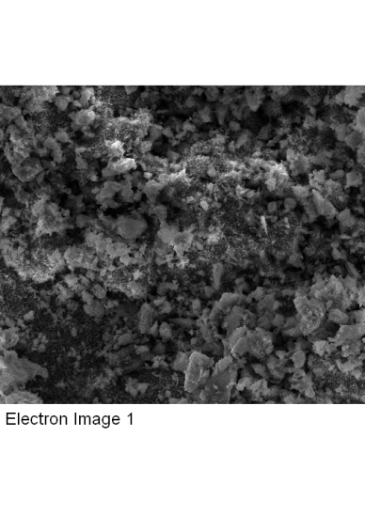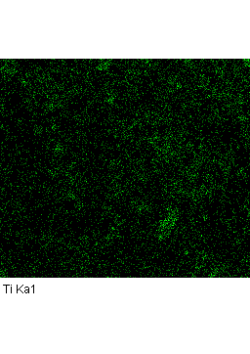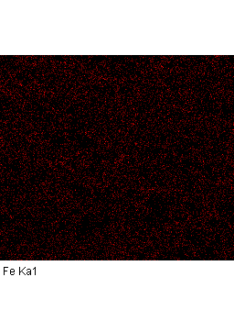

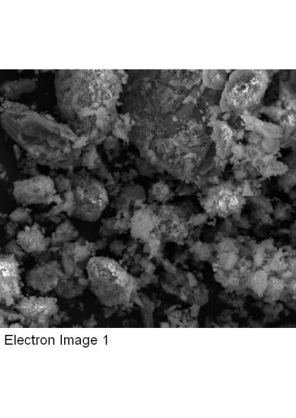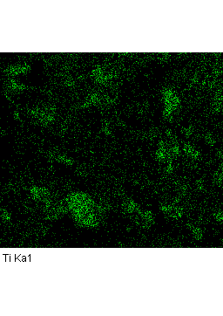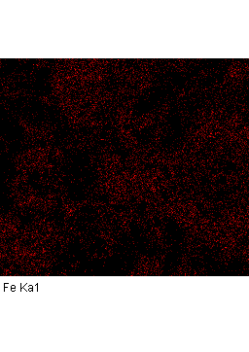

**(A)**

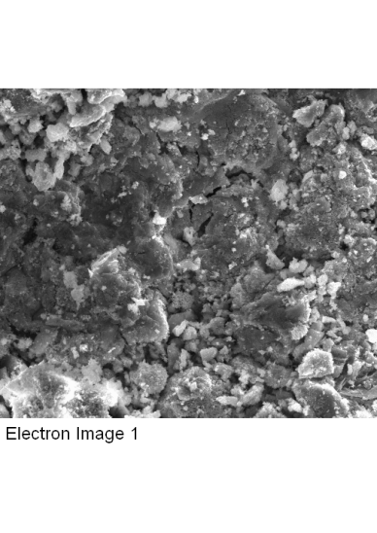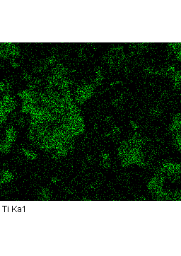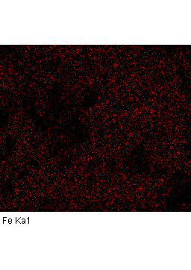

**(B)**

**(C)**

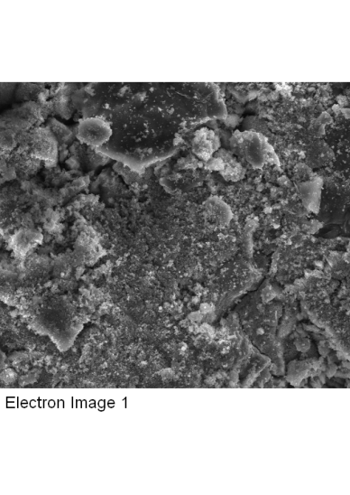

**(D)**

**Figure S2.** Elemental mapping analysis for **(A)** Fe2O3/TiO2/Mt, **(B)** Fe2O3/TiO2/Al-PILCCM, **(C)** Fe2O3/TiO2/Al-PILCAE, and **(D)** Fe2O3/TiO2/Al-PILCBE at 20% Ti and 20% Fe. Green (Ti Ka1), Red (Fe Ka1).



**C12H7Cl3O2**

**C12H8Cl2O4**

**C6H4Cl2O**

**C6H4Cl2O2**

**C6H5ClO2**









**Figure S3.** The extracted ion chromatograms (XIC) of TCS and its by-products.



**Figure S4.** HPLC-Chromatogram (200nm) of Fenton reaction’s solutions of TCS during the reaction, from 5 to 240 minutes.



**C6H4Cl2O**

**C6H4Cl2O2**

**C6H2Cl2O2**

**C6H4O4**









**C6H4O2**

**Figure S5.** The extracted ion chromatograms (XIC) of 2,6-DCP and its by-products.



**C15H16O2**



**C15H16O3**

**C15H14O3**

**C9H10O**



**C8H8O2**

**Figure S6.** The extracted ion chromatograms (XIC) of BPA and its by-products.